**Introduction to Data Structures & Algorithms**

**Data Structures and Algorithms:**

Let's clear up our basics with these terms before deep diving into DSA.  Data Structures and Algorithms are two different things.

**Data Structures** –  These are like the ingredients you need to build efficient algorithms. These are the ways to arrange data so that they (data items) can be used efficiently in the main memory. Examples: Array, Stack, Linked List, and many more. You don't need to worry about these names. These topics will be covered in detail in the upcoming tutorials.

**Algorithms** – Sequence of steps performed on the data using efficient data structures to solve a given problem, be it a basic or real-life-based one.  Examples include: sorting an array.

**Some other Important terminologies:**

1. **Database** – Collection of information in permanent storage for faster retrieval and updation. Examples are MySql, MongoDB, etc.
2. **Data warehouse** – Management of huge data of legacy data( the data we keep at a different place from our fresh data in the database to make the process of retrieval and updation fast) for better analysis.
3. **Big data** – Analysis of too large or complex data, which cannot be dealt with the traditional data processing applications.

**Memory Layout of C Programs:**

* When the program starts, its code gets copied to the main memory.
* **The stack** holds the memory occupied by functions. It stores the activation records of the functions used in the program. And erases them as they get executed.
* **The heap** contains the data which is requested by the program as dynamic memory using pointers.
* **Initialized and uninitialized data** segments hold initialized and uninitialized global variables, respectively.

Take a look at the below diagram for a better understanding:

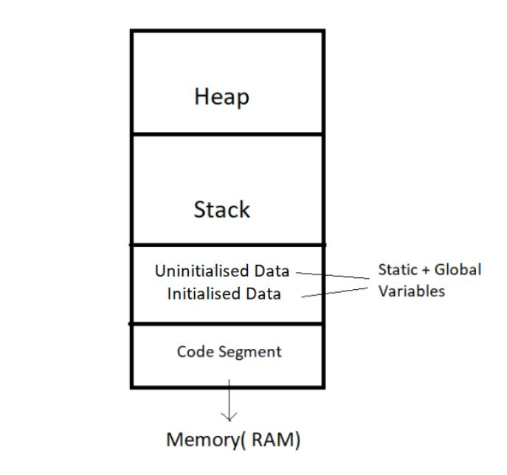

So, this was all for the beginning. Data Structures and Algorithms are not new concepts. If you have done programming in any language like C, you must have come across  Arrays – A data structure. And algorithms are just sequences of processing steps to solve a problem. :)

# Time Complexity and Big O Notation

**An analogy to a real-life issue:**

* This morning I wanted to eat some pizza; So, I asked my brother to get me some from Dominos, which is 3 km away.
* He got me the pizza, and I was happy only to realize it was too little for 29 friends who came to my house for a surprise visit!
* My brother can get 2 pizzas for me on his bike, but pizza for 29 friends is too huge of an input for him, which he cannot handle.

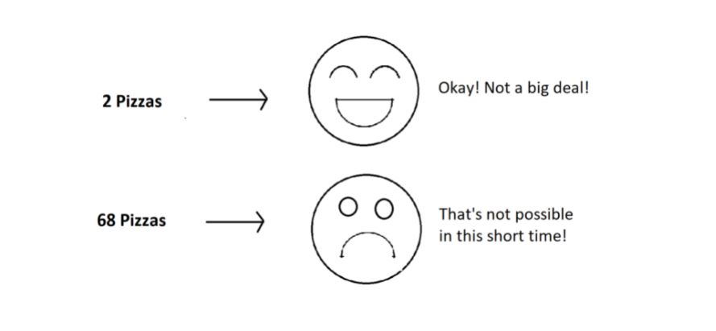

**What is Time Complexity?**

Time Complexity is the study of the efficiency of algorithms. It tells us how much time is taken by an algorithm to process a given input. Let's understand this concept with the help of an example:

Consider two developers Shubham and Rohan, who created an algorithm to sort ‘n’ numbers independently. When I made the program run for some input size n, the following results were recorded:

|  |  |  |
| --- | --- | --- |
| **No. of elements (n)** | **Time Taken By Shubham’s Algo** | **Time Taken By Rohan’s Algo** |
| 10 elements | 90 ms | 122 ms |
| 70 elements | 110 ms | 124 ms |
| 110 elements | 180 ms | 131 ms |
| 1000 elements | 2s | 800 ms |

We can see that at first, Shubham's algorithm worked well with smaller inputs; however, as we increase the number of elements, Rohan's algorithm performs much better.

**Quick Quiz:**Who’s algorithm is better?

**Time Complexity: Sending GTA 5 to a friend:**

* Imagine you have a friend who lives 5 km away from you. You want to send him a game. Since the final exams are over and you want him to get this 60 GB file worth of game from you. How will you send it to him in the shortest time possible?
* Note that both of you are using JIO 4G with a 1 Gb/day data limit.
* The best way would be to send him the game by delivering it to his house. Copy the game to a hard disk and make it reach him physically.
* Would you do the same for sending some small-sized game like MineSweeper which is in KBS of size? Of Course no, because you can now easily send it via the Internet.
* As the file size grows, the time taken to send the game online increases linearly – O(n) while the time taken by sending it physically remains constant. O(n0) or O(1).

Calculating Order in terms of Input Size:

In order to calculate the order(time complexity), the most impactful term containing n is taken into account (Here n refers to Size of input). And the rest of the smaller terms are ignored.

Let us assume the following formula for the algorithms in terms of input size n:

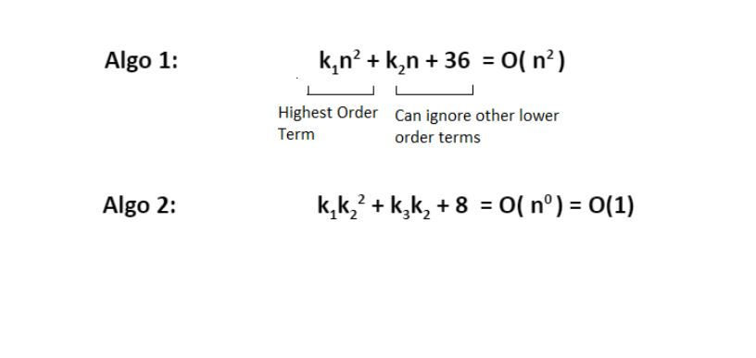

Here, we ignored the smaller terms in algo 1 and carried the most impactful term, which was the square of the input size. Hence the time complexity became n^2. The second algorithm followed just a constant time complexity.

Note that these are the formulas for the time taken by their program.

What is a Big O?

Putting it simply, big O stands for ‘order of’ in our industry, but this is pretty different from the mathematical definition of the big O. Big O in mathematics stands for all those complexities our program runs in. But in industry, we are asked the minimum of them. So this was a subtle difference.

**Visualizing Big O:**

If we were to plot O(1) and O(n) on a graph, they would look something like this:

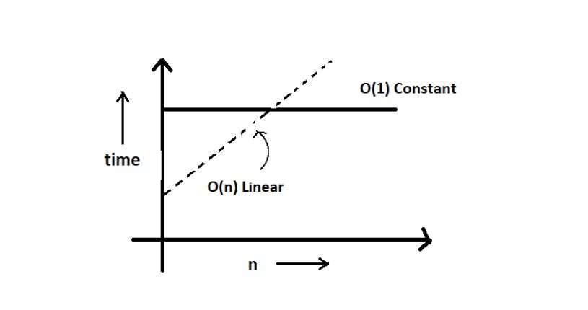

So, this was the basics of time complexities.

**Asymptotic Notations: Big O, Big Omega and Big Theta Explained (With Notes)**

Asymptotic notation gives us an idea about how good a given algorithm is compared to some other algorithm.

Now let's look at the mathematical definition of 'order of.' Primarily there are three types of widely used asymptotic notations.

1. Big oh notation ( O )
2. Big omega notation ( Ω )
3. Big theta notation ( θ ) – Widely used one

**Big oh notation ( O ):**

* Big oh notation is used to describe an asymptotic upper bound.
* Mathematically, if f(n) describes the running time of an algorithm; f(n) is O(g(n)) if and only if there exist positive constants c and n° such that:

0 ≤ f(n) ≤ c g(n) for all n ≥ n°.

* Here, n is the input size, and g(n) is any complexity function, for, e.g. n, n2, etc. (It is used to give upper bound on a function)
* If a function is O(n), it is automatically O(n2) as well! Because it satisfies the equation given above.

**Graphic example for Big oh ( O ):**

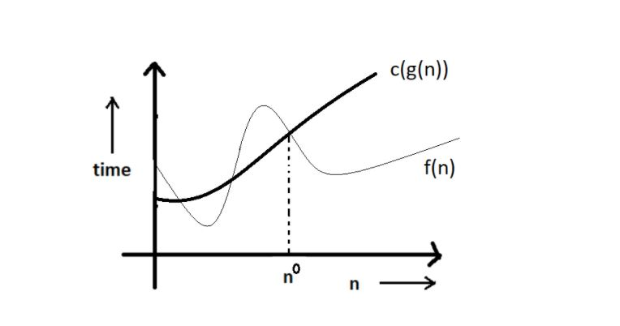

**Big Omega Notation ( Ω ):**

* Just like O notation provides an asymptotic upper bound, Ω notation provides an asymptotic lower bound.
* Let f(n) define the running time of an algorithm; f(n) is said to be Ω (g(n)) if and only if there exist positive constants  c and n° such that:

0 ≤ c g(n) ≤ f(n) for all n ≥ n°.

* It is used to give the lower bound on a function.
* If a function is Ω (n2) it is automatically Ω (n) as well since it satisfies the above equation.

**Graphic example for Big Omega (Ω):**

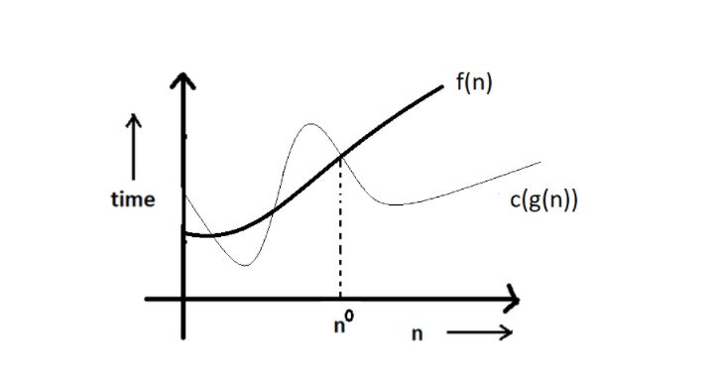

**Big theta notation ( θ ):**

* Let f(n) define the running time of an algorithm.
* F(n) is said to be θ (g(n)) if f(n) is O (g(n)) and f(x) is Ω (g(n)) both.

Mathematically,

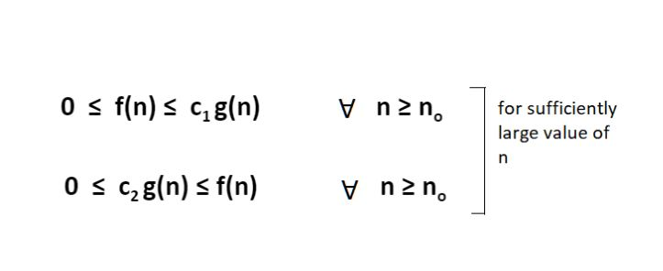

Merging both the equations, we get:

0 ≤ c2 g(n) ≤ f(n) ≤ c1 g(n) ∀ n ≥ no.

The equation simply means that there exist positive constants c1 and c2 such that f(n) is sandwiched between c2 g(n) and c1 g(n).

**Graphic example of Big theta ( θ ):**

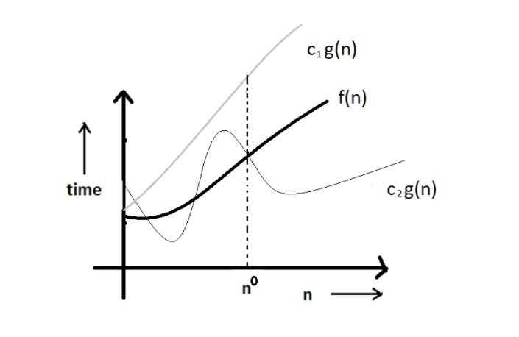

**Which one of these to use?**

Big theta provides a better picture of a given algorithm's run time, which is why most interviewers expect you to answer in terms of Big theta when they ask "order of" questions. And what you provide as the answer in Big theta, is already a Big oh and a Big omega. It is recommended for this reason.

**Quick Quiz:** Prove that n2+n+1 is O(n3), Ω(n2), and θ(n2) using respective definitions.

**Hint:**You can approach this both graphically, making some rough graphs and mathematically, finding valid constants c1 and c2.

**Increasing order of common runtimes:**

Below mentioned are some common runtimes which you will come across in your coding career.

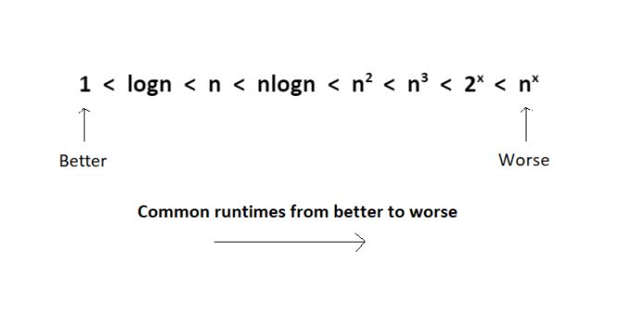

So, this was all about the asymptotic notations.

**Best Case, Worst Case and Average Case Analysis of an Algorithm (With Notes)**

Life can sometimes be lucky for us:

* Exams getting canceled when you are not prepared, a surprise test when you are prepared, etc.   →**Best case**

Occasionally, we may be unlucky:

* Questions you never prepared being asked in exams, or heavy rain during your sports period, etc.  → **Worst case**

However, life remains balanced overall with a mixture of these lucky and unlucky times. →**Expected case**

Those were the analogies between the study of cases and our everyday lives. Our fortunes fluctuate from time to time, sometimes for the better and sometimes for the worse. Similarly, a program finds it best when it is effortless for it to function. And worse otherwise.

By considering a search algorithm used to perform a sorted array search, we will analyze this feature.

**Analysis of a search algorithm:**

Consider an array that is sorted in increasing order.

|  |  |  |  |  |  |
| --- | --- | --- | --- | --- | --- |
| 1 | 7 | 18 | 28 | 50 | 180 |

We have to search a given number in this array and report whether it’s present in the array or not. In this case, we have two algorithms, and we will be interested in analyzing their performance separately.

1. **Algorithm 1** – Start from the first element until an element greater than or equal to the number to be searched is found.
2. **Algorithm 2** – Check whether the first or the last element is equal to the number. If not, find the number between these two elements (center of the array); if the center element is greater than the number to be searched, repeat the process for the first half else, repeat for the second half until the number is found. And this way, keep dividing your search space, making it faster to search.

**Analyzing Algorithm 1: (Linear Search)**

* We might get lucky enough to find our element to be the first element of the array. Therefore, we only made one comparison which is obviously constant for any size of the array.
* Best case complexity = O(1)
* If we are not that fortunate, the element we are searching for might be the last one. Therefore, our program made ‘n’ comparisons.
* Worst-case complexity = O(n)

For calculating the average case time, we sum the list of all the possible case’s runtime and divide it with the total number of cases. Here, we found it to be just O(n). (Sometimes, calculation of average-case time gets very complicated.)

**Analyzing Algorithm 2: (Binary Search)**

* If we get really lucky, the first element will be the only element that gets compared. Hence, a constant time.
* Best case complexity = O(1)
* If we get unlucky, we will have to keep dividing the array into halves until we get a single element. (that is, the array gets finished)
* Hence the time taken : n + n/2 +n/4 + . . . . . . . . . . + 1  = logn with base 2
* Worst-case complexity = O(log n)

**What is log(n)?**

Logn refers to how many times I need to divide n units until they can no longer be divided (into halves).

* log8 = 3  ⇒  8/2  + 4/2  + 2/2   →    Can’t break anymore.
* log4 = 2  ⇒  4/2  + 2/2   →    Can’t break anymore.

You can refer to the graph below, and you will find how slowly the time complexity (Y-axis) increases when we increase the input n (X-axis).

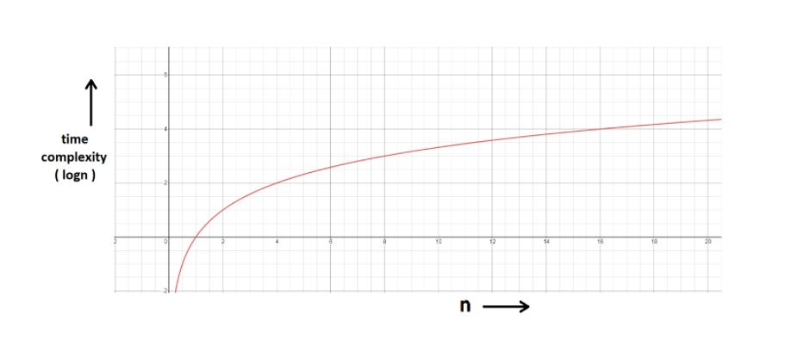

**Space Complexity:**

* Time is not the only thing we worry about while analyzing algorithms. Space is equally important.
* Creating an array of size n (size of the input) **→** O (n) Space
* If a function calls itself recursively n times, its space complexity is O (n).

**Quiz Quiz:** Calculate the space complexity of a function that calculates the factorial of a given number n.

**Hint:**Use recursion.

You might have wondered at some point why we can't calculate complexity in seconds when dealing with time complexities. Here's why:

* Not everyone’s computer is equally powerful. So we avoid handling absolute time taken. We just measure the growth of time with an increase in the input size.
* Asymptotic analysis is the measure of how time (runtime) grows with input.

# How to Calculate Time Complexity of an Algorithm + Solved Questions (With Notes)

In previous videos, we had discussed what time complexity is and how it helps in dealing with what is most efficient for our programs. Our task today will be to find out how to calculate the time complexity of our programs. Here are some tips and tricks about the same, followed by a discussion of some questions.

#### Techniques to calculate Time Complexity:

Once we are able to write the runtime in terms of the size of the input (n), we can find the time complexity. For example:

T(n) = n2 → O(n^2)

T(n) = logn → O(logn)

#### Here are some tricks to calculate complexities:

##### **Drop the constants:**

Anything you might think is O(kn) (where k is a constant) is O(n) as well. This is considered a better representation of the time complexity since the k term would not affect the complexity much for a higher value of n.

##### **Drop the non-dominant terms: :**

Anything you represent as O(n2+n) can be written as O(n2). Similar to when non-dominant terms are ignored for a higher value of n.

##### **Consider all variables which are provided as input:**

O (mn) and O (mnq) might exist for some cases.

In most cases, we try to represent the runtime in terms of the inputs which can even be more than one in number. For example,

The time taken to paint a park of dimension m * n → O (kmn) → O (mn)

#### Time Complexity – Competitive Practice Sheet:

Question1: Fine the time complexity of the func1 function in the program shown in the snippet below:

#include<stdio.h>

void func1(int array[], int length)

{

int sum=0;

int product =1;

for (int i = 0; i <length; i++)

{

sum+=array[i];

}

for (int i = 0; i < length; i++)

{

product*=array[i];

}

}

int main()

{

int arr[] = {3,4,66};

func1(arr,3);

return 0;

}

Question 2: Find the time complexity of the func function in the program from program2.c as follows:

void func(int n)

{

int sum=0;

int product =1;

for (int i = 0; i <n; i++)

{

for (int j = 0; j < n; j++)

{

printf("%d , %d\n", i,j);

}

}

}

Question 3: Consider the recursive algorithm below, where the random(int n) spends one unit of time to return a random integer where the probability of each integer coming as random is evenly distributed within the range [0,n]. If the average processing time is T(n), what is the value of T(6)?

int function(int n)

{

int i = 0;

if (n <= 0)

{

return 0;

}

else

{

i = random(n - 1);

printf("this\n");

return function(i) + function(n - 1 - i);

}

}

Question 4: Which of the following are equivalent to O(N) and why?

1. O(N + P), where P < N/9
2. 0(9N-k)
3. O(N + 8log N)
4. O(N + M2)

Question 5: The following simple code sums the values of all the nodes in a balanced binary search tree ( don’t worry about what it is, we’ll learn them later ). What is its runtime?

int sum(Node node)

{

if (node == NULL)

{

return 0;

}

return sum(node.left) + node.value + sum(node.right);

}

Question 6: Find the complexity of the following code which tests whether a given number is prime or not?

int isPrime(int n)

{

if (n == 1)

{

return 0;

}

for (int i = 2; i * i < n; i++)

{

if (n % i == 0)

{

return 0;

}

}

return 1;

}

Question 7: What is the time complexity of the following snippet of code?

int isPrime(int n)

{

for (int i = 2; i * i < 10000; i++)

{

if (n % i == 0)

{

return 0;

}

}

return 1;

}

isPrime();

So, these were the few questions I felt like discussing. Try them on your own first. And if you have already given them enough thought, then move on to the video above where we have discussed their solutions in detail.

# Arrays and Abstract Data Type in Data Structure (With Notes)

Today, we will learn about what an abstract data type is. This will just be an introduction. We’ll implement these ideas in our next tutorial. Let's start with the basics.

#### Abstract Data Types and Arrays:

ADTs or abstract data types are the ways of classifying data structures by providing a minimal expected interface and some set of methods. It is very similar to when we make a blueprint before actually getting into doing some job, be it constructing a computer or a building. The blueprint comprises all the minimum required logistics and the roadmap to pursuing the job.

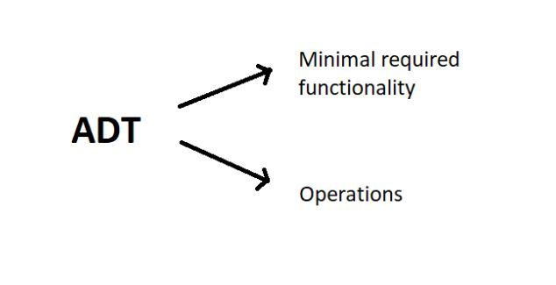

#### Array - ADT

An array ADT holds the collection of given elements (can be int, float, custom) accessible by their index.

##### **1. Minimal required functionality:**

We have two basic functionalities of an array, a get function to retrieve the element at index i and a set function to assign an element to some index in the array.

* get (i) – get element i
* set (i, num) – set element i to num.

##### **2. Operations:-**

We can have a whole lot of different operations on the array we created, but we’ll limit ourselves to some basic ones.

* Max()
* Min()
* Search ( num )
* Insert ( i, num )
* Append (x)

#### Static and Dynamic Arrays:

* Static arrays – Size cannot be changed
* Dynamic arrays – Size can be changed

**Quick Quiz**- Code the operations mentioned above in C language by creating array ADT.

**Hint:** Use structures.

#### Memory Representations of Array:https://cwh-full-next-space.fra1.digitaloceanspaces.com/videos/data-structures-and-algorithms-in-hindi-6/Image_2.webp

* Elements in an array are stored in contiguous memory locations.
* Elements in an array can be accessed using the base address in constant time → O (1).
* Although changing the size of an array is not possible, one can always reallocate it to some bigger memory location. Therefore resizing in an array is a costly operation.

So, this was enough discussing the basics of an array ADT. It is now time to implement these data types through our codes. Even if you are not very familiar with these languages or need a quick brush-up, you can always move on to my easily accessible C or C++ playlist.

**Array as An Abstract Data Type in Data Structures(With Notes)**

In the last video, we learned what abstract data types are. In this video, we will be interested in implementing an array as an abstract data type. Giving it a quick revision, an abstract data type is just another data type as an int or float, with some user-defined methods and operations. It's a kind of customized data type.

Suppose we want to build an array as an abstract data type with our customized set of values and customized set of operations in a heap. Let’s name this customized array myArray.

Let our set of values which will represent our customized array include these parameters:

* total_size
* used_size
* base_address

And the operations include operators namely,

* max()
* get(i)
* set(i,num)
* add(another_array)

So, now when we are done creating a blueprint of the customized array. We can very easily code their implementation, but before that, let’s first learn what these values and operations, we have defined, do:

**Understanding the ADT above:**

1. total_size: This stores the total reserved size of the array in the memory location.
2. used_size: This stores the size of the memory location used.
3. base_address: This is a pointer that stores the address of the first element of the array.

Let the below-illustrated array be an example of what we are talking about.

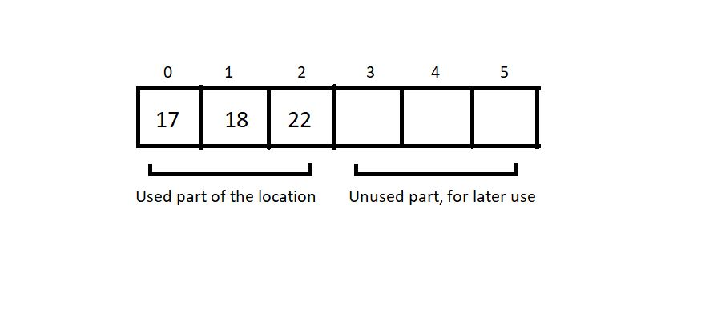

Here, the total_size returns 6, and the used_size returns 3.

We will keep the code implementation of the above ADT for the next tutorial. You can even give it a try on your editors. Use structs and define that set of values with proper data types. The next session will teach us that anyway.

# Implementing Array as an Abstract Data Type in C Language

In the last tutorial, we discussed the blueprint of our customized abstract data type, myArray. In case you missed it, make sure you check it out. Today, we will learn to write the code to implement that array with all the previously defined sets of values and operations.

#### Editor settings:

I will recommend you to use MinGW w64-bit compiler to compile your C programs and VS Code as your code editors. VS Code is highly recommended for its versatility with all the programming languages in the market. You can even check out my Youtube video covering all of this. Let’s, for now, assume that you all have your setup ready. I have attached the code snippet for creating the above ADT array below. Let's check it out.

#### Understanding the snippet below:

1. First, we will define a structure. You can use a class and its methods in C++, but in C, a structure is used to define customized data types.
2. Keep the blueprint we made in the last tutorial by your side. Define the structure elements, integer variables total_size and used_size, and an integer pointer to point at the address of the first element.
3. We are now ready with our customized data type. Let’s define some functions, which will feature

* Creating an array of this data type,
* Printing the contents of this array,
* Setting values in this array.

Create a void function createArray by passing the address of a struct data type a, and integers tSize and uSize. We can very easily assign this tSize and uSize given from the main, to the total_size and used_size of the struct myArray a by either of the methods defined below.

(*a).total_size = tSize;

or

a->total_size = tSize;

***Code Snippet 1: Syntax for assigning structure elements to structure pointers.***

Similarly, assign the integer pointer ptr, the address of the reserved memory location using malloc. Do use the header file <stdlib.h> for using malloc.

a->ptr = (int *)malloc(tSize * sizeof(int));

***Code Snippet 2: Using malloc***

4. We will now create a show function to display all the elements of the struct myArray. We will simply pass the address of the struct myArray a. To print all the elements, we will traverse through the whole struct and print each struct element till the iterator reaches the last element. We will use a→used_size to define the loop size. Use (a→ptr)[i] to access each element.

5.We will now create a setVal function to set values to this struct myArray a and pass the address of the same. Use scanf to assign values to each element via (a→ptr)[i] .

#include<stdio.h>

#include<stdlib.h>

struct myArray

{

int total_size;

int used_size;

int *ptr;

};

void createArray(struct myArray * a, int tSize, int uSize){

// (*a).total_size = tSize;

// (*a).used_size = uSize;

// (*a).ptr = (int *)malloc(tSize * sizeof(int));

a->total_size = tSize;

a->used_size = uSize;

a->ptr = (int *)malloc(tSize * sizeof(int));

}

void show(struct myArray *a){

for (int i = 0; i < a->used_size; i++)

{

printf("%d\n", (a->ptr)[i]);

}

}

void setVal(struct myArray *a){

int n;

for (int i = 0; i < a->used_size; i++)

{

printf("Enter element %d", i);

scanf("%d", &n);

(a->ptr)[i] = n;

}

}

int main(){

struct myArray marks;

createArray(&marks, 10, 2);

printf("We are running setVal now\n");

setVal(&marks);

printf("We are running show now\n");

show(&marks);

return 0;

}

***Code Snippet 3: A program to implement the ADT array***

So, these were the basic methods we could define for this struct. We’ll check if these work by running it. We’ll call the createArray, and setVal functions first to create an array of size 2, and assign some values to it. And then call the show function to see if it works.

#### Output of the above program:

Enter element 0 : 12

Enter element 1 : 13

We are running show now

12

13

PS D:\MyData\Business\code playground\Ds & Algo with Notes\Code>

And this was implementing the myArray ADT. I hope you all could follow it. Possibly there were some syntaxes you were not familiar with, but don't worry, take your time. Watch the other courses regarding them on my Youtube channel.

Thank you for being with me throughout. I hope you enjoyed the tutorial. If you appreciate my work, please let your friends know about this course too. If you haven’t checked out the whole playlist yet, move on to [codewithharry.com](https://www.codewithharry.com/) or my YouTube channel to access it. See you all in the next tutorial where we’ll learn to operate on this array using several operators. Till then keep learning.

#### Here is the source code we wrote in the video!

#include<stdio.h>

#include<stdlib.h>

struct myArray

{

int total_size;

int used_size;

int *ptr;

};

void createArray(struct myArray * a, int tSize, int uSize){

// (*a).total_size = tSize;

// (*a).used_size = uSize;

// (*a).ptr = (int *)malloc(tSize * sizeof(int));

a->total_size = tSize;

a->used_size = uSize;

a->ptr = (int *)malloc(tSize * sizeof(int));

}

void show(struct myArray *a){

for (int i = 0; i < a->used_size; i++)

{

printf("%d\n", (a->ptr)[i]);

}

}

void setVal(struct myArray *a){

int n;

for (int i = 0; i < a->used_size; i++)

{

printf("Enter element %d", i);

scanf("%d", &n);

(a->ptr)[i] = n;

}

}

int main(){

struct myArray marks;

createArray(&marks, 10, 2);

printf("We are running setVal now\n");

setVal(&marks);

printf("We are running show now\n");

show(&marks);

return 0;

}

# Operations on Arrays in Data Structures: Traversal, Insertion, Deletion and Searching

In the last tutorial, we discussed implementing our abstract data type array and its set of values. In today's lesson, we'll explore how we can operate on these arrays. For example: traversing through the array, sorting the array, and many more. We’ll start with the primary ones.

#### Operations on an Array:

While there are many operations that can be implemented and studied, we only need to be familiar with the primary ones at this point.  An array supports the following operations:

* Traversal
* Insertion
* Deletion
* Search

Other operations include sorting ascending, sorting descending, etc. Let's follow up on these individually.

#### Traversal:

Visiting every element of an array once is known as **traversing** the array.

##### Why Traversal?

For use cases like:

* Storing all elements – Using scanf()
* Printing all elements – Using printf()
* Updating elements.

An array can easily be traversed using a for loop in C language.

##### An important note on Arrays:

If we create an array of length 100 using a[100] in C language, we need not use all the elements. It is possible for a program to use just 60 elements out of these 100. (But we cannot go beyond 100 elements).

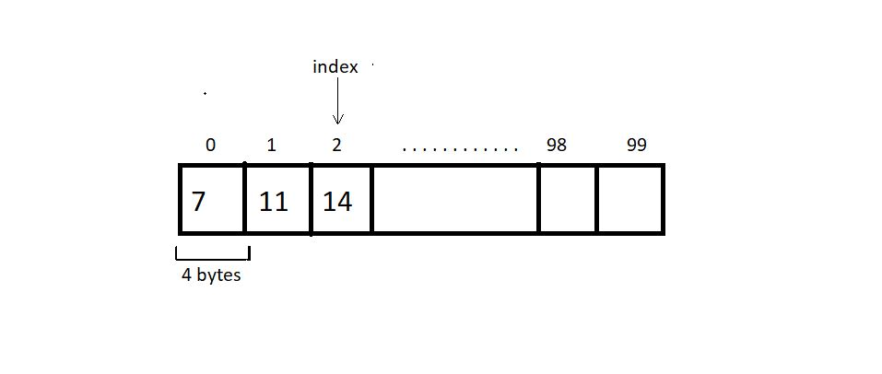

#### Insertion:

An element can be inserted in an array at a specific position. For this operation to succeed, the array must have enough capacity. Suppose we want to add an element 10 at index 2 in the below-illustrated array, then the elements after index 1 must get shifted to their adjacent right to make way for a new element.

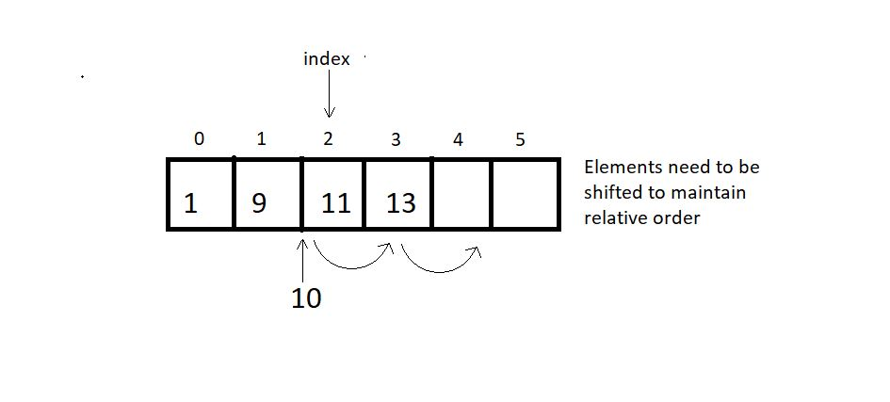

When no position is specified, it’s best to insert the element at the end to avoid shifting, and this is when we achieve the best runtime O(1).

#### Deletion:

An element at a specified position can be deleted, creating a void that needs to be fixed by shifting all the elements to their adjacent left, as illustrated in the figure below.

We can also bring the last element of the array to fill the void if the relative ordering is not important. :)

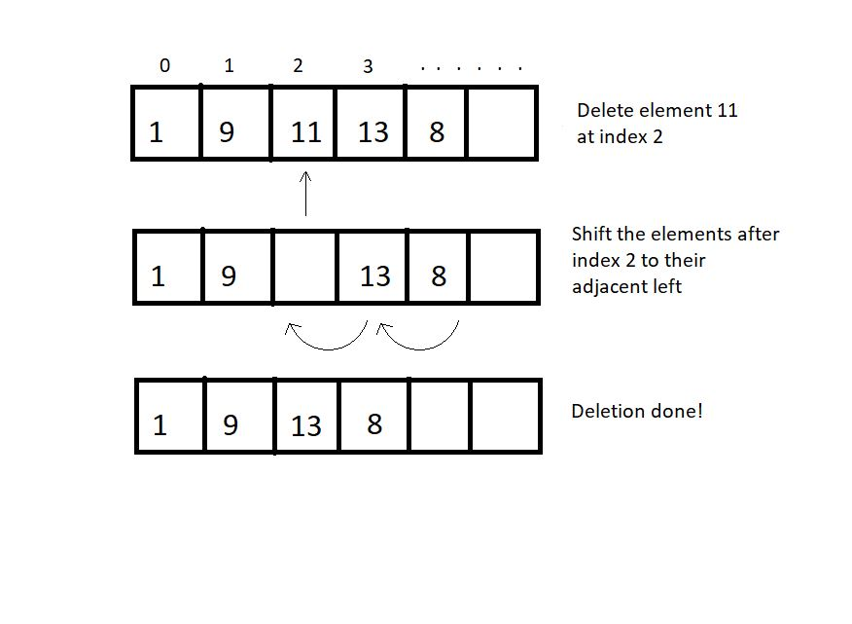

**Quick Quiz:**What is the best and the worst runtime for a delete operation?

#### Searching:

Searching can be done by traversing the array until the element to be searched is found.O(n) There is still a better method. As you may remember, we talked about binary search in some previous tutorials.  Don't forget to look it up if you missed it. We had analyzed both linear and binary search. This search method is only applicable for sorted arrays. Therefore, for sorted arrays, the time taken to search is much less than an unsorted array. O(logn)

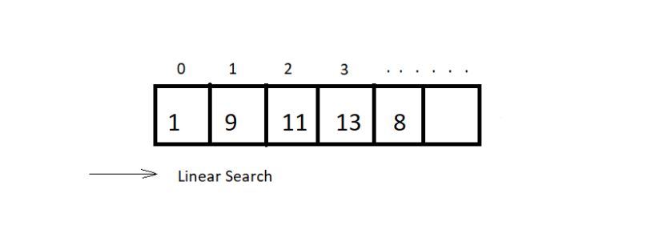

#### Sorting:

Sorting means arranging an array in an orderly fashion (ascending or descending). We have different algorithms to sort arrays. We’ll see various sorting techniques later in the course.

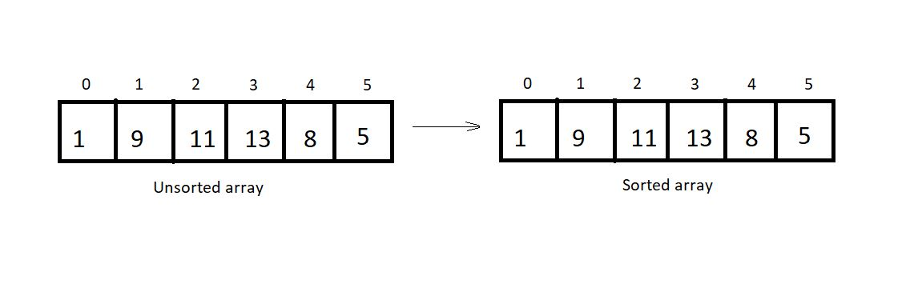

So, these were few primary operators for an abstract data type array

**Coding Insertion Operation in Array in Data Structures in C language**

In the last tutorial, we discussed all the primary operators and the concepts behind each. Today, we will learn how to code their algorithms. But before that, let’s give ourselves a quick revision.

We talked about four operations-basically, **traversal**, **insertion**, **deletion,** and **searching**. As already mentioned, traversal is not any big a deal. It can just be achieved by using a *for*loop. Our main objective today would be to implement insertion. So, let’s slide our chairs to our coding arena. I have attached the code snippet below.

**Understanding code snippet 1:**

1. We will start by declaring an array *arr*of length 100. Initialize this array with some 4-5 elements. This will be our used memory.
2. We’ll create a void *display* function using the method of traversal. Pass this array to the display function by value or by reference. And print the elements. Printing the elements of an array has already been covered in my C playlist. Visit now if you haven’t yet.
3. We’ll now create an integer function *indInsertion* (integer, just to check if the operation succeeds). Before that, create an integer variable *size* to store the used size of the array. Pass into this void function the array and its used size, the element to be inserted and the total size, and the index where it is inserted.

indInsertion(arr, size, element, 100, index);

1. In the *indInsertion*function, write the case of validity. Here, we’ll check if the index is within the range [0,100]. We’ll continue if it's valid; otherwise, return -1.
2. Create a *for*loop to shift the elements from the index to the last element to their adjacent right. This way, we’ll create a void at the index we want to insert in.
3. Insert the element in the index. Return 1 on completion.
4. #include<stdio.h>

7. void display(int arr[], int n){
8. // Code for Traversal
9. for (int i = 0; i < n; i++)
10. {
11. printf("%d ", arr[i]);
12. }
13. printf("\n");
14. }
16. int indInsertion(int arr[], int size, int element, int capacity, int index){
17. // code for Insertion
18. if(size>=capacity){
19. return -1;
20. }
21. for (int i = size-1; i >=index; i--)
22. {
23. arr[i+1] = arr[i];
24. }
25. arr[index] = element;
26. return 1;
27. }
29. int main(){
30. int arr[100] = {7, 8, 12, 27, 88};
31. int size = 5, element = 45, index=1;
32. display(arr, size);
33. indInsertion(arr, size, element, 100, index);
34. size +=1;
35. display(arr, size);
36. return 0;
37. }

***Code Snippet 1: Insertion Operation Algorithm***

Output of the above program:

7 8 12 27 88

7 45 8 12 27 88

So, as you can see, element 45 got inserted at index 1, and the rest of the elements from this index to the last shifted to their right. And this is how we do an insertion in an array.

**Coding Deletion Operation in Array Using C Language (With Notes)**

In the last tutorial, we had learned about the first two primary operations in an array ADT, traversal and insertion. Today, we will study the third one, *deletion*.

Programming a deletion differs very slightly from programming an insertion. In insertion, we had to shift elements to their adjacent right to create a void at the desired place to insert a new element, but in deletion, we’ll shift the elements to their adjacent left to fill the void created after deleting an element at some index.

Let us now code this out or rather transform the code we constructed to insert the element. I have attached the snippet below.

**Understanding code snippet 1:**

1. One thing which will remain as it is, is the display function.
2. We have to make minimal changes in the insertion function to make it a deletion function. Rename it *indDeletion.*The index and the array, and its size will be our only parameters this time.
3. Replace the right shift with the left shift. Just assign array[i], the value present in array[i+1].
4. And we are done deleting the element at some specified index.

#include <stdio.h>

void display(int arr[], int n)

{

// Code for Traversal

for (int i = 0; i < n; i++)

{

printf("%d ", arr[i]);

}

printf("\n");

}

void indDeletion(int arr[], int size, int index)

{

// code for Deletion

for (int i = index; i < size-1; i++)

{

arr[i] = arr[i + 1];

}

}

int main()

{

int arr[100] = {7, 8, 12, 27, 88};

int size = 5, element = 45, index = 0;

display(arr, size);

indDeletion(arr, size, index);

size -= 1;

display(arr, size);

return 0;

}

**Code Snippet 1: Deletion in an array:**

We can now check if the program actually works for deleting the element at some index. We’ll create an array with 5 elements and display it before and after deleting an element at index 0.

Refer to the output below:

7 8 12 27 88

8 12 27 88

PS D:\MyData\Business\code playground\Ds & Algo with Notes\Code>

**Figure 1: Output of the above program**

So, the code works fine. Element at index 0 got deleted, and the rest of the elements shifted left to fill the void created after deletion.  And this was all about the deletion. Only a subtle change of code helped transform insertion into deletion.

# Linear Vs Binary Search + Code in C Language (With Notes)

We have already covered the first three operators in an array, namely traversal, insertion, and deletion. Today, we will learn about the search operations in an array.

You must already be familiar with these two methods we have for searching in an array, linear and binary search. We had used them quite a bit in our previous tutorials. We had analyzed them and got the result that for a sorted array, the fastest method to search is the binary one. Today, we’ll learn how to code them and practically use them to search.

#### Linear Search:

This search method searches for an element by visiting all the elements sequentially until the element is found or the array finishes. It follows the array traversal method.

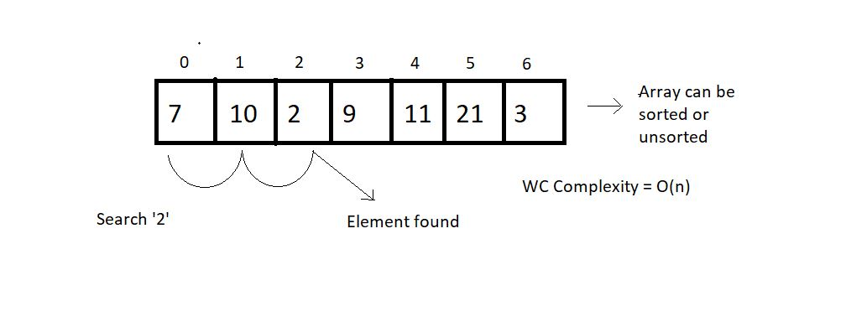

#### Binary Search:

This search method searches for an element by breaking the search space into half each time it finds the wrong element. This method is limited to a sorted array. The search continues towards either side of the mid, based on whether the element to be searched is lesser or greater than the mid element of the current search space.

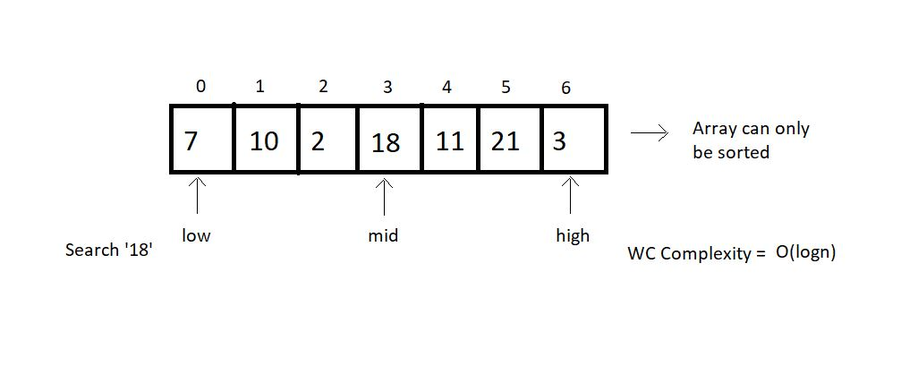

From the above illustrations, we can draw a comparison between both the search methods based on their choice of arrays, operations, and worst-case complexities.

|  |  |  |
| --- | --- | --- |
|  | **Linear Search** | **Binary Search** |
| 1. | Works on both sorted and unsorted arrays | Works only on sorted arrays |
| 2. | Equality operations | Inequality operations |
| 3. | O(n) WC Complexity | O(log n) WC Complexity |

**Table 1: Linear Search VS Binary Search**

Let us now move on to the coding part of these methods. I have attached the snippet below. Refer to it while understanding.

Understanding the code snippet 1:

##### Linear Search:

1. We’ll start with coding the linear search. Create an integer function linearSearch. This function will receive the array, its size, and the element to be searched as its parameters.

2. Run a for loop from its 0 to the last index, checking the if condition at every index whether the element at that index equals the search element. If yes, return the index, else continue the search.

3. If the element could not be found until the last, return -1.

##### Binary Search:

1. Create a function named binarySearch and pass the same three parameters as we did in linear search. Here, we will maintain three integer variables low, mid, and high. Low  stores are the beginning of the search space, and high stores the end. Mid stores the middle element of our search space, which is   mid = (low+high)/2.

2. Check whether the mid element equals the search element. If yes, return mid, else if the mid element is greater than the search element, then the search element must lie on the left side of the current space and high becomes mid-1, else if the mid element is less than the search element, then we’ll shift to the right side, and low becomes mid+1.

3. This way, we reduce our search space into half every time we repeat step 2. Now our new mid becomes (low+high)/2, and we repeat step 2. And keep repeating until either we find the search element or the low becomes greater than the high.

#include<stdio.h>

int linearSearch(int arr[], int size, int element){

for (int i = 0; i < size; i++)

{

if(arr[i]==element){

return i;

}

}

return -1;

}

int binarySearch(int arr[], int size, int element){

int low, mid, high;

low = 0;

high = size-1;

// Keep searching until low <= high

while(low<=high){

mid = (low + high)/2;

if(arr[mid] == element){

return mid;

}

if(arr[mid]<element){

low = mid+1;

}

else{

high = mid -1;

}

}

return -1;

}

int main(){

// Unsorted array for linear search

// int arr[] = {1,3,5,56,4,3,23,5,4,54634,56,34};

// int size = sizeof(arr)/sizeof(int);

// Sorted array for binary search

int arr[] = {1,3,5,56,64,73,123,225,444};

int size = sizeof(arr)/sizeof(int);

int element = 444;

int searchIndex = binarySearch(arr, size, element);

printf("The element %d was found at index %d \n", element, searchIndex);

return 0;

}

**Code Snippet 1: Linear search and Binary search codes.**

Let’s check if it works. Refer to the output below:

The element 444 was found at index 8

PS D:\MyData\Business\code playground\Ds & Algo with Notes\Code>

So from the above output, you can conclude that our code works all fine. So, we are done implementing both these search methods. Binary Search holds great importance in the world of programming. We’ll come across several algorithms following binary search.

# Introduction to Linked List in Data Structures (With Notes)

Linked lists are the new data structure we'll explore today. The study of linked lists will certainly be detailed, but first, I would like to inform you about one of the fundamental differences between linked lists and arrays.

Arrays demand a contiguous memory location. Lengthening an array is not possible. We would have to copy the whole array to some bigger memory location to lengthen its size. Similarity inserting or deleting an element causes the elements to shift right and left, respectively.

But linked lists are stored in a non-contiguous memory location. To add a new element, we just have to create a node somewhere in the memory and get it pointed by the previous element. And deleting an element is just as easy as that. We just have to skip pointing to that particular node. Lengthening a linked list is not a big deal.

#### Structure of a Linked List:

Every element in a linked list is called a node and consists of two parts, the data part, and the pointer part. The data part stores the value, while the pointer part stores the pointer pointing to the address of the next node.

Both of these structures (arrays and linked lists) are linear data structures.

#### Linked Lists VS Arrays:

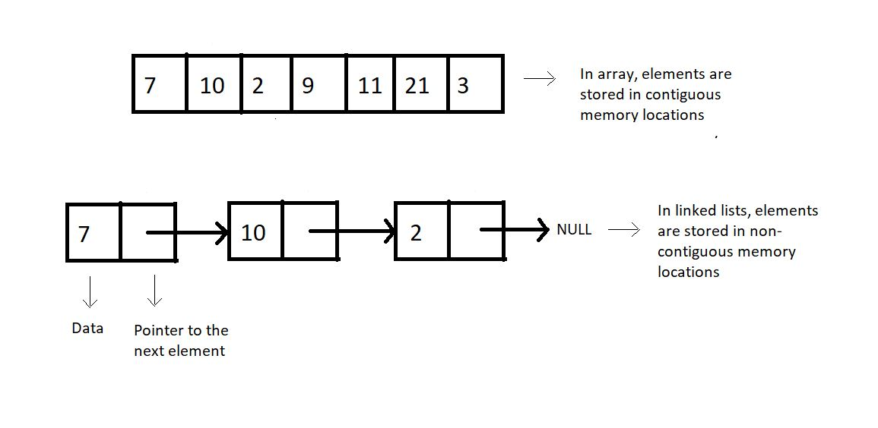

**Figure 1: Arrays vs. Linked lists**

#### Why Linked Lists?

Memory and the capacity of an array remain fixed, while in linked lists, we can keep adding and removing elements without any capacity constraint.

##### Drawbacks of Linked Lists:

* Extra memory space for pointers is required (for every node, extra space for a pointer is needed)
* Random access is not allowed as elements are not stored in contiguous memory locations.

#### ****Implementations****

Linked lists are implemented in C language using a structure. You can refer to the snippet below.

**Understanding the snippet below:**

1. We construct a structure named Node.
2. Define two of its members, an integer data, which holds the node's data, and a structure pointer, next, which points to the address of the next structure node.

struct Node

{

int data;

struct Node *next; // Self referencing structure

};

**Code Snippet 1: Implementation of a linked list**

**Linked List Data Structure: Creation and Traversal in C Language**

In the last tutorial, we saw the differences between a linked list and an array. We saw the advantages and the limitations of a linked list. Today, we’ll cover more on a linked lists’ creation and learn how to traverse through it. If you haven't already, I recommend that you first go through the last tutorial.

I would anyway want to point some important things we learned about linked lists:

1. These are stored in non-contiguous memory locations.
2. Insertion and deletion in a linked list are very efficient in comparison to arrays.
3. An element called node holds the value as well as a pointer to the next element.

We can now move onto coding them. I've attached the snippet below for your referral. Follow them while understanding the same.

**Understanding the snippet below:**

1. An element in a linked list is a *struct Node.* It is made to hold integer *data*and a pointer of data type *struct Node*,*as it has to point to another *struct Node.*

2. We’ll create the below illustrated linked list.

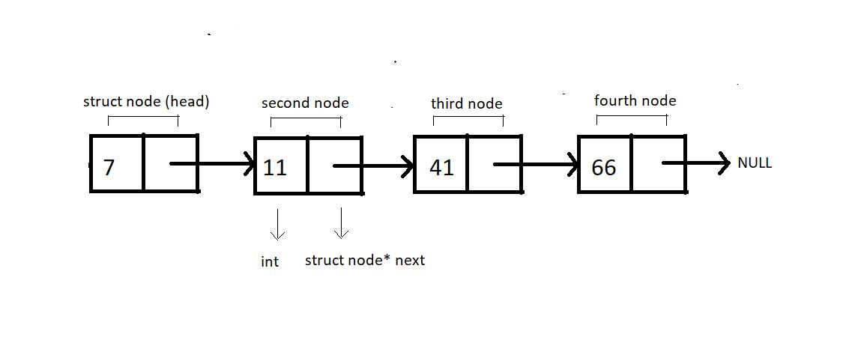

**Figure 1: Illustration of the below implemented linked list.**

3. We will always create individual nodes and link them to the next node via the arrow operator ‘→’.

4. First, we’ll define a structure *Node* and create two of its members, an int variable *data,*to store the current node's value and a struct node* pointer variable *next.*

5. Now, we can move on to our main() and start creating these nodes. We’ll name the first node, *head.*Define a pointer to head node by *struct node* head.*And similarly for the other nodes. Request the memory location for each of these nodes from heap via malloc using the below snippet.

head = (struct Node *)malloc(sizeof(struct Node));

6. Link these nodes using the arrow operator and call the traversal function.

7. Create a void function *linkedlistTraversal* and pass into it the pointer to the head node.

8. Run a while loop while the pointer doesn’t point to a NULL. And keep changing the pointer *next*each time you are done printing the data of the current node.

#include <stdio.h>

#include <stdlib.h>

struct Node

{

int data;

struct Node *next;

};

void linkedListTraversal(struct Node *ptr)

{

while (ptr != NULL)

{

printf("Element: %d\n", ptr->data);

ptr = ptr->next;

}

}

int main()

{

struct Node *head;

struct Node *second;

struct Node *third;

struct Node *fourth;

// Allocate memory for nodes in the linked list in Heap

head = (struct Node *)malloc(sizeof(struct Node));

second = (struct Node *)malloc(sizeof(struct Node));

third = (struct Node *)malloc(sizeof(struct Node));

fourth = (struct Node *)malloc(sizeof(struct Node));

// Link first and second nodes

head->data = 7;

head->next = second;

// Link second and third nodes

second->data = 11;

second->next = third;

// Link third and fourth nodes

third->data = 41;

third->next = fourth;

// Terminate the list at the third node

fourth->data = 66;

fourth->next = NULL;

linkedListTraversal(head);

return 0;

}

**Code Snippet 1: Creating and traversing in a linked list**

Let’s check if it works all fine. Refer to the output below.

Element: 7

Element: 11

Element: 41

Element: 66

PS D:\MyData\Business\code playground\Ds & Algo with Notes\Code>

**Figure 2: Output of the above program**

So, this was successfully creating and traversing through the linked list.

**Insertion of a Node in a Linked List Data Structure**

In the last tutorial, we had learned about creating a linked list using C structures and traversing through them while printing the values at each node. Today, we’ll learn how to insert a node at some position and how that is more efficient than inserting an element in an array.

Inserting in an array has already been covered, and the following remarks were made:

1. A void has to be made to insert an element.
2. Creating a void causes the rest of the elements to shift to their adjacent right.
3. Time complexity: O(no. of elements shifted)

**Inserting in a linked list:**

Consider the following Linked List,

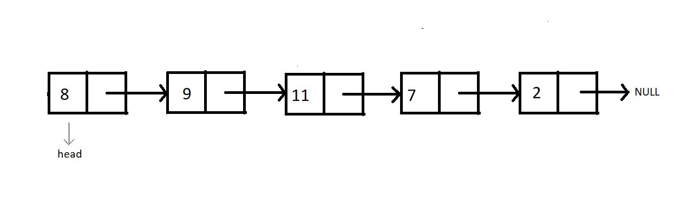

Insertion in this list can be divided into the following categories:

**Case 1**: Insert at the beginning

**Case 2**: Insert in between

**Case 3**: Insert at the end

**Case 4**: Insert after the node

For insertion following any of the above-mentioned cases, we would first need to create that extra node. And then, we overwrite the current connection and make new connections. And that is how we insert a new node at our desired place.

**Syntax for creating a node:**

struct Node *ptr = (struct Node*) malloc (sizeof (struct Node))

The above syntax will create a node, and the next thing one would need to do is set the data for this node.

ptr -> data = 9

This will set the data.

Now, let's begin with each of these cases of insertion.

**Case 1: Insert at the beginning**

In order to insert the new node at the beginning, we would need to have the head pointer pointing to this new node and the new node’s pointer to the current head.

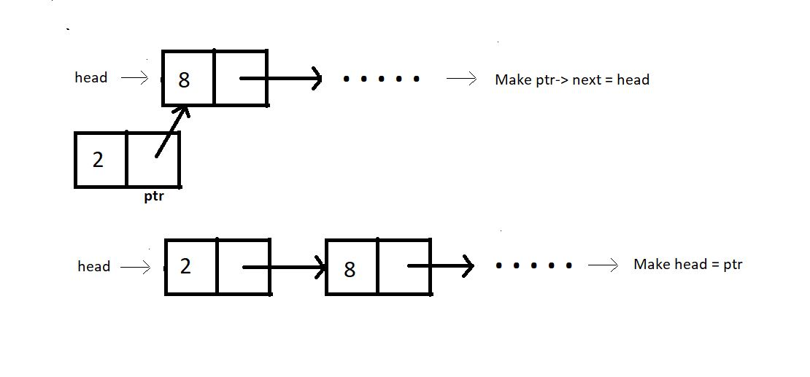

**Case 2: Insert in between:**

Assuming index starts from 0, we can insert an element at index i>0 as follows:

1. Bring a temporary pointer p pointing to the node before the element you want to insert in the linked list.
2. Since we want to insert between 8 and 2, we bring pointer p to 8.

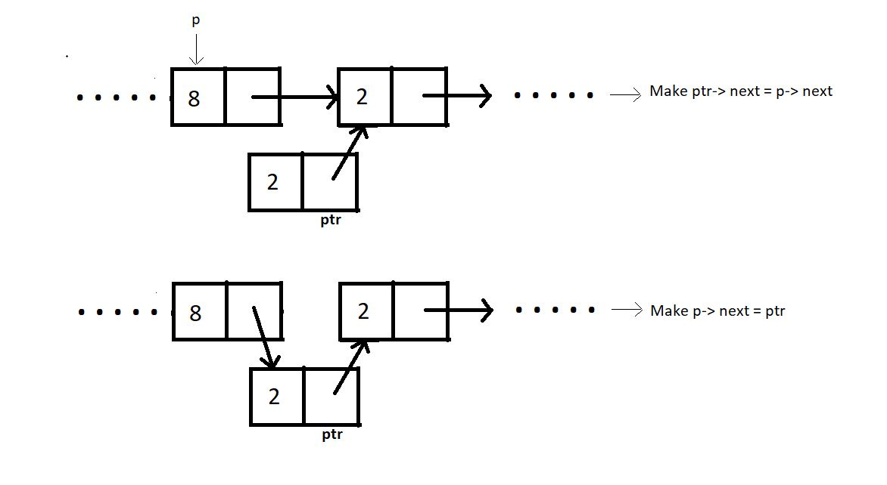

**Case 3: Insert at the end:**

In order to insert an element at the end of the linked list, we bring a temporary pointer to the last element.

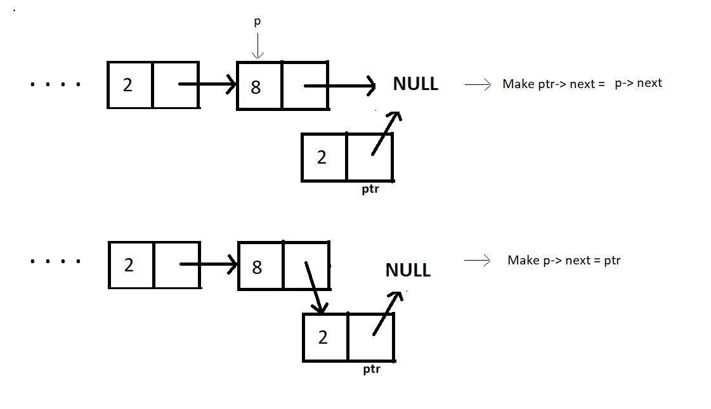

**Case 4: Insert after a node:**

Similar to the other cases, ptr can be inserted after a node as follows:

ptr->next = prevNode-> next;

prevNode-> next = ptr;

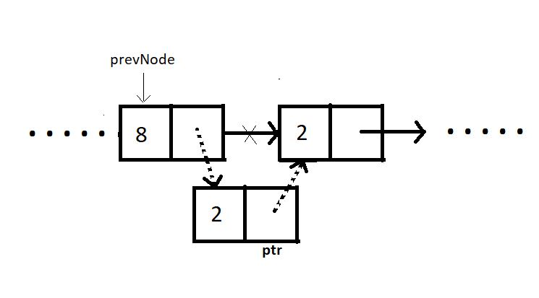

Summarizing, inserting at the beginning has the time complexity O(1), and inserting at some node in between puts the time complexity O(n) since we have to go through the list to reach that particular node. Inserting at the end has the same time complexity O(n) as that of inserting in between. But if we are given the pointer to the previous node where we want to insert the new node, it would just take a constant time O(1).

**Insertion in a Linked List in C Language**

So, since we are already finished learning about all the cases one would have encountered while inserting a new node into a linked list, we can now code them individually in C language.

Before we code, let’s recall all the cases:

1. Inserting at the beginning        -> Time complexity:  O(1)
2. Inserting in between                 -> Time complexity:  O(n)
3. Inserting at the end                   -> Time complexity:  O(n)
4. Inserting after a given Node     -> Time complexity:  O(1)

Let’s now code. I have attached the snippet below. Refer to it while understanding the steps.

Understanding the snippet below:

1. So, the first thing would be to create a struct *Node.*This is a known thing to us. We have covered this in our traversal video.
2. Create the *linkedlistTraversal*function. Earlier tutorials can be referred to.
3. Do include the header file <stdlib.h>, since we’ll be using malloc to reserve memory locations.
4. As we did last time, create the same four nodes, the first node being the *head.*Define a pointer to head node by *struct node* head.*And similarly for the other nodes. Request the memory location for each of these nodes from the heap via malloc. Link these nodes using the arrow operator.
5. Now that we have created a linked list, we can create functions according to the different cases.

Insertion at the beginning:

1. Create a struct Node* function *insertAtFirst* which will return the pointer to the new head.
2. We’ll pass the current head pointer and the data to insert at the beginning, in the function.
3. Create a new struct Node* pointer *ptr*, and assign it a new memory location in the heap.
4. Assign head to the next member of the ptr structure using ptr-> next = head, and the given data to its data member.
5. Return this pointer *ptr.*
6. // Case 1
7. struct Node * insertAtFirst(struct Node *head, int data){
8. struct Node * ptr = (struct Node *) malloc(sizeof(struct Node));
9. ptr->data = data;
11. ptr->next = head;
12. return ptr;
13. }

***Code Snippet 1: Implementing insertAtFirst.***

**Insertion in between:**

1. Create a struct Node* function *insertAtIndex* which will return the pointer to the head.
2. We’ll pass the current head pointer and the data to insert and the index where it will get inserted, in the function.
3. Create a new struct Node* pointer *ptr*, and assign it a new memory location in the heap.
4. Create a new struct Node* pointer pointing to *head*, and run a loop until this pointer reaches the index, where we are inserting a new node.
5. Assign p->next to the next member of the ptr structure using ptr-> next = p->next, and the given data to its data member.
6. Break the connection between p and p->next by assigning p->next the new pointer. That is, p->next = ptr.
7. Return head.

// Case 2

struct Node * insertAtIndex(struct Node *head, int data, int index){

struct Node * ptr = (struct Node *) malloc(sizeof(struct Node));

struct Node * p = head;

int i = 0;

while (i!=index-1)

{

p = p->next;

i++;

}

ptr->data = data;

ptr->next = p->next;

p->next = ptr;

return head;

}

***Code Snippet 2: Implementing insertAtIndex.***

Insertion at the end:

1. Inserting at the end is very similar to inserting at any index. The difference holds in the limit of the while loop. Here we run a loop until the pointer reaches the end and points to NULL.
2. Assign NULL to the next member of the new ptr structure using ptr-> next = NULL, and the given data to its data member.
3. Break the connection between p and NULL by assigning p->next the new pointer. That is, p->next = ptr.
4. Return head.

// Case 3

struct Node * insertAtEnd(struct Node *head, int data){

struct Node * ptr = (struct Node *) malloc(sizeof(struct Node));

ptr->data = data;

struct Node * p = head;

while(p->next!=NULL){

p = p->next;

}

p->next = ptr;

ptr->next = NULL;

return head;

}

***Code Snippet 3: Implementing insertAtEnd.***

**Insertion after a given node:**

1. Here, we already have a struct Node* pointer to insert the new node just next to it.
2. Create a struct Node* function *insertAfterNode* which will return the pointer to the head.
3. Pass into this function, the head node, the previous node, and the data.
4. Create a new struct Node* pointer *ptr*, and assign it a new memory location in the heap.
5. Since we already have a struct Node* *prevNode*given as a parameter, use it as p we had in the previous functions.
6. Assign prevNode->next to the next member of the ptr structure using ptr-> next = prevNode->next, and the given data to its data member.
7. Break the connection between prevNode and prevNode->next by assigning prevNode->next the new pointer. That is, prevNode->next = ptr.
8. Return head.
9. // Case 4
10. struct Node * insertAfterNode(struct Node *head, struct Node *prevNode, int data){
11. struct Node * ptr = (struct Node *) malloc(sizeof(struct Node));
12. ptr->data = data;
14. ptr->next = prevNode->next;
15. prevNode->next = ptr;
17. return head;
18. }

**Code Snippet 4: Implementing *insertAfterNode*.**

So those were the cases we had in insertion. Below is the whole source code.

#include<stdio.h>

#include<stdlib.h>

struct Node{

int data;

struct Node * next;

};

void linkedListTraversal(struct Node *ptr)

{

while (ptr != NULL)

{

printf("Element: %d\n", ptr->data);

ptr = ptr->next;

}

}

// Case 1

struct Node * insertAtFirst(struct Node *head, int data){

struct Node * ptr = (struct Node *) malloc(sizeof(struct Node));

ptr->data = data;

ptr->next = head;

return ptr;

}

// Case 2

struct Node * insertAtIndex(struct Node *head, int data, int index){

struct Node * ptr = (struct Node *) malloc(sizeof(struct Node));

struct Node * p = head;

int i = 0;

while (i!=index-1)

{

p = p->next;

i++;

}

ptr->data = data;

ptr->next = p->next;

p->next = ptr;

return head;

}

// Case 3

struct Node * insertAtEnd(struct Node *head, int data){

struct Node * ptr = (struct Node *) malloc(sizeof(struct Node));

ptr->data = data;

struct Node * p = head;

while(p->next!=NULL){

p = p->next;

}

p->next = ptr;

ptr->next = NULL;

return head;

}

// Case 4

struct Node * insertAfterNode(struct Node *head, struct Node *prevNode, int data){

struct Node * ptr = (struct Node *) malloc(sizeof(struct Node));

ptr->data = data;

ptr->next = prevNode->next;

prevNode->next = ptr;

return head;

}

int main(){

struct Node *head;

struct Node *second;

struct Node *third;

struct Node *fourth;

// Allocate memory for nodes in the linked list in Heap

head = (struct Node *)malloc(sizeof(struct Node));

second = (struct Node *)malloc(sizeof(struct Node));

third = (struct Node *)malloc(sizeof(struct Node));

fourth = (struct Node *)malloc(sizeof(struct Node));

// Link first and second nodes

head->data = 7;

head->next = second;

// Link second and third nodes

second->data = 11;

second->next = third;

// Link third and fourth nodes

third->data = 41;

third->next = fourth;

// Terminate the list at the third node

fourth->data = 66;

fourth->next = NULL;

printf("Linked list before insertion\n");

linkedListTraversal(head);

// head = insertAtFirst(head, 56);

// head = insertAtIndex(head, 56, 1);

// head = insertAtEnd(head, 56);

head = insertAfterNode(head, third, 45);

printf("\nLinked list after insertion\n");

linkedListTraversal(head);

return 0;

}

# Deletion in a Linked List | Deleting a node from Linked List Data Structure

In the last two tutorials, we got to see how one can insert a node in a linked list. Today, we’ll learn how to delete a node at some position. It will draw quite similarities with inserting a node, so this might be easy to you as well.

#### Inserting in a linked list:

Consider the following Linked List:  
Insertion in this list can be divided into the following categories:

**Case 1**: Deleting the first node.

**Case 2**: Deleting the node at the index.

**Case 3**: Deleting the last node.

**Case 4**: Deleting the first node with a given value.

For deletion, following any of the above-mentioned cases, we would just need to free that extra node left after we disconnect it from the list. Before that, we overwrite the current connection and make new connections. And that is how we delete a node from our desired place.

##### Syntax for freeing a node:

free(ptr);

The above syntax will free this node, that is, remove its reserved location in the heap.

Now, let's begin with each of these cases of insertion.

#### Case 1: Insert at the beginning:

In order to delete the node at the beginning, we would need to have the head pointer pointing to the node second to the head node, that is, head-> next. And we would simply free the node that’s left.

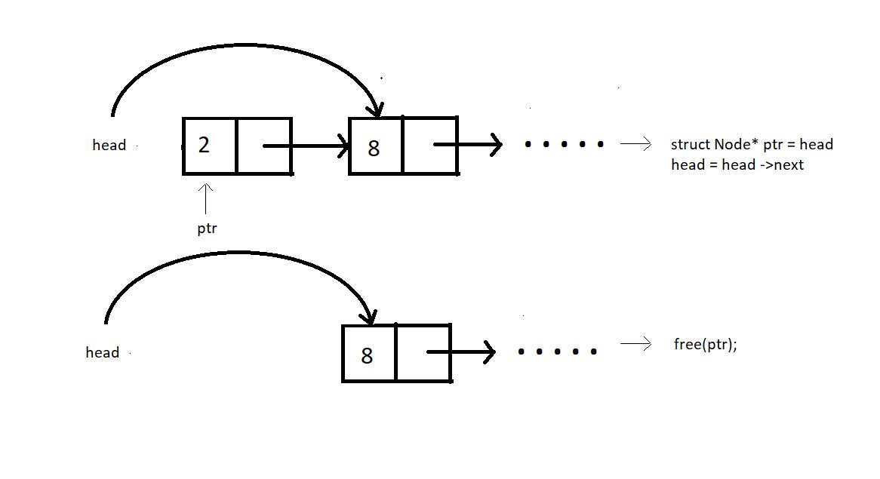

#### Case 2: Deleting at some index in between:

Assuming index starts from 0, we can delete an element from index i>0 as follows:

1. Bring a temporary pointer p pointing to the node before the element you want to delete in the linked list.
2. Since we want to delete between 2 and 8, we bring pointer p to 2.
3. Assuming ptr points at the element we want to delete.
4. We make pointer p point to the next node after pointer ptr skipping ptr.
5. We can now free the pointer skipped.

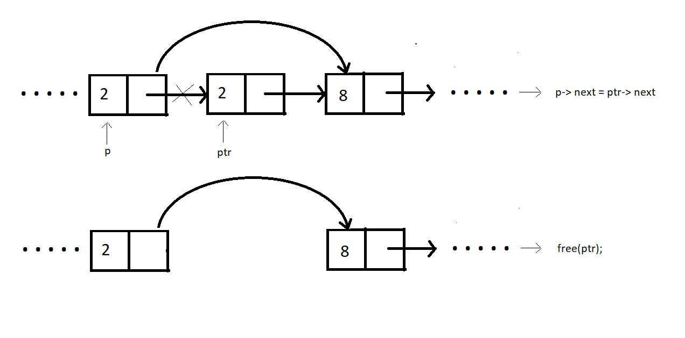

#### Case 3: Deleting at the end:

In order to delete an element at the end of the linked list, we bring a temporary pointer ptr to the last element. And a pointer p  to the second last. We make the second last element to point at NULL. And we free the pointer ptr.

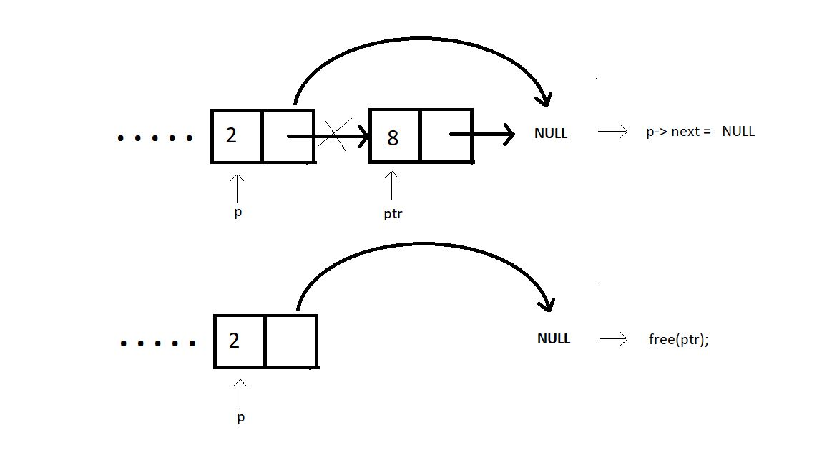

#### Case 4: Delete the first node with a given value:

Similar to the other cases, ptr can be deleted for a given value as well by following few steps:

1. p->next = givenVal-> next;
2. free(givenVal);

Since, the value 8 comes twice in the list, this function will be made to delete only the first occurrence.

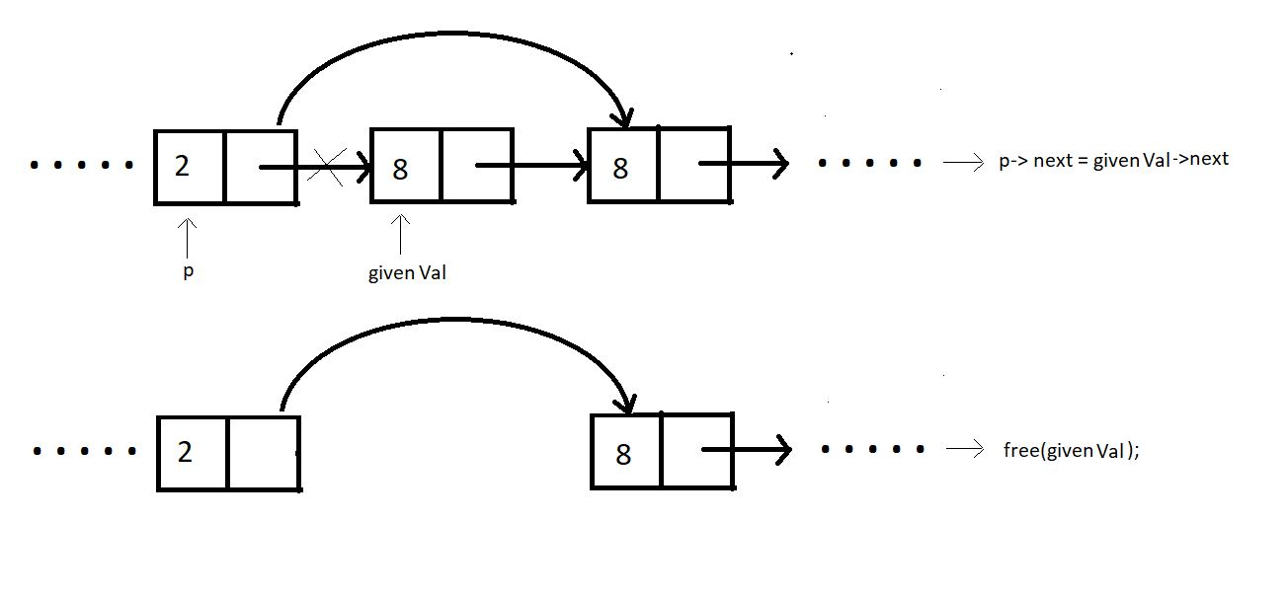

Learning about the time complexity while deleting these nodes, we found that deleting the element at the beginning completes in a constant time, i.e O(1). Deleting at any index in between is no big deal either, it just needs the pointer ptr to reach the node to be deleted, causing it to follow O(n). And the same goes with case 3 and case 4. We have to traverse through the list to reach that desired position.

# Delete a Node from Linked List (C Code For Deletion From Beginning, End, Specified Position & Key)

Now that we have a thorough understanding of all the cases that we will encounter when deleting an existing node from a linked list, we can code each one in C language.

Before we code, let’s recall all the cases:

1. Deleting the first node            -> Time complexity:  O(1)
2. Deleting a node in between   -> Time complexity:  O(n)
3. Deleting the last node            -> Time complexity:  O(n)
4. Deleting the element with a given value from the linked list     -> Time complexity:  O(n)

Now, let's move on to the coding part. I have attached the snippet below. Refer to it while understanding the steps.

**Understanding the snippet below:**

1. You should have a good understanding of how to declare struct Nodes and traverse linked lists by now.
2. So, the first thing would be to create a struct Node and create the linkedlistTraversal function.
3. Do include the header file <stdlib.h>, since we’ll use malloc to reserve memory locations.
4. Similar to what we did in the insertion video, create the four(choose any number) nodes. Request the memory location for each of these nodes from the heap via malloc. Link these nodes using the arrow operator.
5. And this is how we create a linked list of size 4. Let’s see the cases of deletion.

#### Deleting the first node :

1. Create a struct Node* function deleteFirst which will return the pointer to the new head after deleting the current head.
2. We’ll pass the current head pointer in the function.
3. Create a new struct Node* pointer ptr, and make it point to the current head.
4. Assign head to the next member of the list, by head = head->next, because this is going to be the new head of the linked list.
5. Free the pointer ptr. And return the head.
6. // Case 1: Deleting the first element from the linked list
7. struct Node * deleteFirst(struct Node * head){
8. struct Node * ptr = head;
9. head = head->next;
10. free(ptr);
11. return head;
12. }

***Code Snippet 1: Deleting the first node***

#### Deleting a node in between:

1. Create a struct Node* function deleteAtIndex which will return the pointer to the head.
2. In the function, we'll pass the current head pointer and the index where the node is to be deleted.
3. Create a new struct Node* pointer p pointing to head.
4. Create a new struct Node* pointer q pointing to head->next, and run a loop until this pointer reaches the index, from where we are deleting the node.
5. Assign q->next to the next member of the p structure using p-> next = q->next.
6. Free the pointer q, because it has zero connections with the list now.
7. Return head.
8. // Case 2: Deleting the element at a given index from the linked list
9. struct Node * deleteAtIndex(struct Node * head, int index){
10. struct Node *p = head;
11. struct Node *q = head->next;
12. for (int i = 0; i < index-1; i++)
13. {
14. p = p->next;
15. q = q->next;
16. }
18. p->next = q->next;
19. free(q);
20. return head;
21. }

**Code Snippet 2: Deleting a node in between**

#### Deleting the last node :

1. Deleting the last node is quite similar to deleting from any other index. The difference holds in the limit of the while loop. Here we run a loop until the pointer reaches the end and points to NULL.
2. Assign NULL to the next member of the p structure using p-> next = NULL.
3. Break the connection between q and NULL by freeing the ptr q.
4. Return head.
5. // Case 3: Deleting the last element
6. struct Node * deleteAtLast(struct Node * head){
7. struct Node *p = head;
8. struct Node *q = head->next;
9. while(q->next !=NULL)
10. {
11. p = p->next;
12. q = q->next;
13. }
15. p->next = NULL;
16. free(q);
17. return head;
18. }

***Code Snippet 3: Deleting the last node***

#### Deleting the element with a given value from the linked list :

1. Here, we already have a value that needs to be deleted from the list. The main thing is that we’ll delete only the first occurrence.
2. Create a struct Node* function deleteByValue which will return the pointer to the head.
3. Pass into this function the head node, the value which needs to be deleted.
4. Create a new struct Node* pointer p pointing to the head.
5. Create another struct Node* pointer q pointing to the next of head.
6. Run a while loop until the pointer q encounters the given value or the list finishes.
7. If it encounters the value, delete that node by making p point the next node, skipping the node q. And free q from memory.
8. And if the list just finishes, it means there was no such value in the list. Continue without doing anything.
9. Return head.
10. // Case 4: Deleting the element with a given value from the linked list
11. struct Node * deleteByValue(struct Node * head, int value){
12. struct Node *p = head;
13. struct Node *q = head->next;
14. while(q->data!=value && q->next!= NULL)
15. {
16. p = p->next;
17. q = q->next;
18. }
20. if(q->data == value){
21. p->next = q->next;
22. free(q);
23. }
24. return head;
25. }

***Code Snippet 4: Deleting the element with a given value from the linked list***

So, this was all about deletion in the linked list data structure.Here is the whole source code:

#include <stdio.h>

#include <stdlib.h>

struct Node

{

int data;

struct Node *next;

};

void linkedListTraversal(struct Node *ptr)

{

while (ptr != NULL)

{

printf("Element: %d\n", ptr->data);

ptr = ptr->next;

}

}

// Case 1: Deleting the first element from the linked list

struct Node * deleteFirst(struct Node * head){

struct Node * ptr = head;

head = head->next;

free(ptr);

return head;

}

// Case 2: Deleting the element at a given index from the linked list

struct Node * deleteAtIndex(struct Node * head, int index){

struct Node *p = head;

struct Node *q = head->next;

for (int i = 0; i < index-1; i++)

{

p = p->next;

q = q->next;

}

p->next = q->next;

free(q);

return head;

}

// Case 3: Deleting the last element

struct Node * deleteAtLast(struct Node * head){

struct Node *p = head;

struct Node *q = head->next;

while(q->next !=NULL)

{

p = p->next;

q = q->next;

}

p->next = NULL;

free(q);

return head;

}

// Case 4: Deleting the element with a given value from the linked list

struct Node * deleteAtIndex(struct Node * head, int value){

struct Node *p = head;

struct Node *q = head->next;

while(q->data!=value && q->next!= NULL)

{

p = p->next;

q = q->next;

}

if(q->data == value){

p->next = q->next;

free(q);

}

return head;

}

int main()

{

struct Node *head;

struct Node *second;

struct Node *third;

struct Node *fourth;

// Allocate memory for nodes in the linked list in Heap

head = (struct Node *)malloc(sizeof(struct Node));

second = (struct Node *)malloc(sizeof(struct Node));

third = (struct Node *)malloc(sizeof(struct Node));

fourth = (struct Node *)malloc(sizeof(struct Node));

// Link first and second nodes

head->data = 4;

head->next = second;

// Link second and third nodes

second->data = 3;

second->next = third;

// Link third and fourth nodes

third->data = 8;

third->next = fourth;

// Terminate the list at the third node

fourth->data = 1;

fourth->next = NULL;

printf("Linked list before deletion\n");

linkedListTraversal(head);

// head = deleteFirst(head); // For deleting first element of the linked list

// head = deleteAtIndex(head, 2);

head = deleteAtLast(head);

printf("Linked list after deletion\n");

linkedListTraversal(head);

return 0;

}

# Circular Linked List and Operations in Data Structures (With Notes)

Till now, we have covered linked lists, which consist of a head, the body, and an end pointing to NULL. Basically, it was linear. We could do traversal, insertion, deletion, searching, and many more operations while traversing to the end of it. Today, we’ll see a variant of it, circular linked lists. We’ll also see all those operations that we could do in a linear linked list and their implementations in a circular linked list.

#### Introduction:

A circular linked list is a linked list where the last element points to the first element (head) hence forming a circular chain. There is no node pointing to the NULL, indicating the absence of any end node. In circular linked lists, we have a head pointer but no starting of this list.

Refer to the illustration of a circular linked list below:

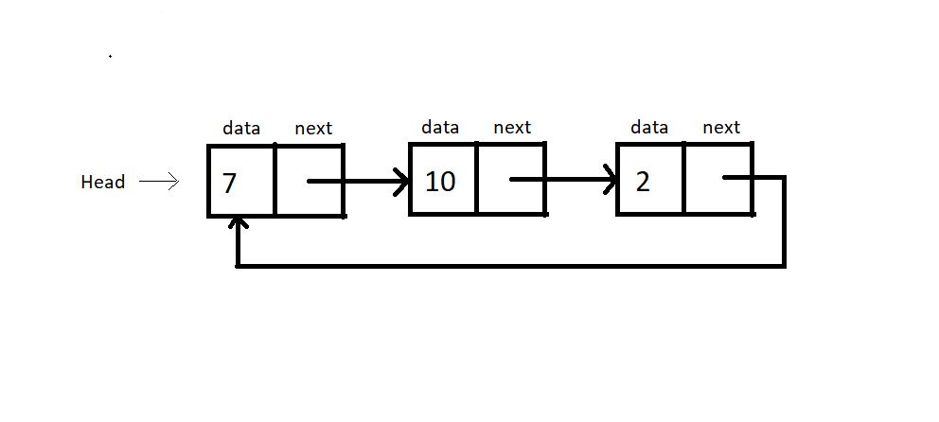

#### Operations on a Circular Linked List:

Operations on circular linked lists can be performed exactly like a singly linked list. It’s just that we have to maintain an extra pointer to check if we have gone through the list once.

#### Traversal:

* Traversal in a circular linked list can be achieved by creating a new struct Node* pointer p, which starts from the head and goes through the list until it points again at the head. So, this is how we go through this circle only once, visiting each node.
* And since traversal is achieved, all the other operations in a circular linked list become as easy as doing things in a linear linked list.
* One thing that may have sounded confusing to you is that there is a head but no starting of this circular linked list. Yes, that is the case; we have this head pointer just to start or incept in this list and for our convenience while operating on it. There is no first element here.

# Circular Linked Lists: Operations in C Language

In the last tutorial, we learned about this new data structure, the circular linked lists. Additionally, we discussed the difference and similarities between a circular linked list and a linear linked list.

Let me quickly summarize some of the most important points:

1. Unlike singly-linked lists, a circular linked list has no node pointing to NULL. Hence it has no end. The last element points at the head node.
2. All the operations can still be done by maintaining an extra pointer fixed at the head node.
3. A circular linked list has a head node, but no starting node.

We even learned traversing through the circular linked list using the do-while approach. Today, we’ll see one of the operations, insertion in a doubly-linked list with the help of C language.

Now, let's move on to the coding part. I have attached the snippet below. Refer to it while understanding the steps.

#### Creating the circular linked list:

1. Creating a circular linked list is no different from creating a singly linked list. One thing we do differently is that instead of having the last element to point to NULL, we’ll make it point to the head.
2. Refer to those previous tutorials while creating these nodes and connecting them. This is the third time we are doing it, and I believe you must have gained that confidence.
3. struct Node
4. {
5. int data;
6. struct Node *next;
7. };
8. int main(){
10. struct Node *head;
11. struct Node *second;
12. struct Node *third;
13. struct Node *fourth;
15. // Allocate memory for nodes in the linked list in Heap
16. head = (struct Node *)malloc(sizeof(struct Node));
17. second = (struct Node *)malloc(sizeof(struct Node));
18. third = (struct Node *)malloc(sizeof(struct Node));
19. fourth = (struct Node *)malloc(sizeof(struct Node));
21. // Link first and second nodes
22. head->data = 4;
23. head->next = second;
25. // Link second and third nodes
26. second->data = 3;
27. second->next = third;
29. // Link third and fourth nodes
30. third->data = 6;
31. third->next = fourth;
33. // Terminate the list at the third node
34. fourth->data = 1;
35. fourth->next = head;
37. return 0;
38. }

**Code Snippet 1: Creating the circular linked list**

#### Traversing the circular linked list:

1. Create a void function linkedListTraversal and pass the head pointer of the linked list to the function.
2. In the function, create a pointer ptr pointing to the head.
3. Run a do-while loop until ptr reaches the last node, and ptr-> next becomes head, i.e. ptr->next = head. And keep printing the data of each node.
4. So, this is how we traverse through a circular linked list. And do-while was the key to make it possible.
5. void linkedListTraversal(struct Node *head){
6. struct Node *ptr = head;
7. do{
8. printf("Element is %d\n", ptr->data);
9. ptr = ptr->next;
10. }while(ptr!=head);
11. }

**Code Snippet 2: Traversing the circular linked list**

#### Inserting into a circular linked list:

1. I’ll just cover the insertion part, and that too on the head. Rest of the variations, I believe, you’ll be able to do yourselves. Things are very similar to that of singly-linked lists.
2. Create a struct Node* function insertAtFirst which will return the pointer to the new head.
3. We’ll pass the current head pointer and the data to insert at the beginning, in the function.
4. Create a new struct Node* pointer ptr, and assign it a new memory location in the heap. This is our new node pointer. Make sure you don't forget to include the header file <stdlib.h>.
5. Create another struct node * pointer p pointing to the next of the head. p = head-> next.
6. Run a while loop until the p pointer reaches the end element and p-> next becomes the head.  
   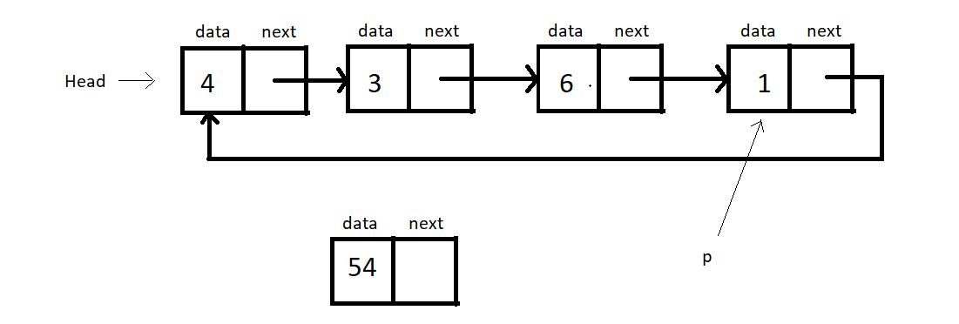
7. Now, assign ptr to the next of p, i.e.p->next  = ptr. And head to  the next of ptr, i.e. ptr->next = head.
8. Now, the new head becomes ptr. head = ptr.**
9. Return head.
10. struct Node * insertAtFirst(struct Node *head, int data){
11. struct Node * ptr = (struct Node *) malloc(sizeof(struct Node));
12. ptr->data = data;
14. struct Node * p = head->next;
15. while(p->next != head){
16. p = p->next;
17. }
18. // At this point p points to the last node of this circular linked list
20. p->next = ptr;
21. ptr->next = head;
22. head = ptr;
23. return head;
25. }

**Code Snippet 3: Inserting into a circular linked list**

##### Here is the whole source code:

#include<stdio.h>

#include<stdlib.h>

struct Node

{

int data;

struct Node *next;

};

void linkedListTraversal(struct Node *head){

struct Node *ptr = head;

do{

printf("Element is %d\n", ptr->data);

ptr = ptr->next;

}while(ptr!=head);

}

struct Node * insertAtFirst(struct Node *head, int data){

struct Node * ptr = (struct Node *) malloc(sizeof(struct Node));

ptr->data = data;

struct Node * p = head->next;

while(p->next != head){

p = p->next;

}

// At this point p points to the last node of this circular linked list

p->next = ptr;

ptr->next = head;

head = ptr;

return head;

}

int main(){

struct Node *head;

struct Node *second;

struct Node *third;

struct Node *fourth;

// Allocate memory for nodes in the linked list in Heap

head = (struct Node *)malloc(sizeof(struct Node));

second = (struct Node *)malloc(sizeof(struct Node));

third = (struct Node *)malloc(sizeof(struct Node));

fourth = (struct Node *)malloc(sizeof(struct Node));

// Link first and second nodes

head->data = 4;

head->next = second;

// Link second and third nodes

second->data = 3;

second->next = third;

// Link third and fourth nodes

third->data = 6;

third->next = fourth;

// Terminate the list at the third node

fourth->data = 1;

fourth->next = head;

return 0;

}

***Code Snippet 4: Insertion and traversal in a circular linked list***

**We’ll now see whether the functions work accurately. Let’s insert a few nodes at the beginning.**

printf("Circular Linked list before insertion\n");

linkedListTraversal(head);

head = insertAtFirst(head, 54);

head = insertAtFirst(head, 58);

head = insertAtFirst(head, 59);

printf("Circular Linked list after insertion\n");

linkedListTraversal(head);

***Code snippet 5: Using the insertAtFirst function***

##### **Refer to the output below:**

Circular Linked list before insertion

Element is 4

Element is 3

Element is 6

Element is 1

Circular Linked list after insertion

Element is 59

Element is 58

Element is 54

Element is 4

Element is 3

Element is 6

Element is 1

As you can see, all the elements we passed into the insertAtFirst function got added at the beginning. So, it is indeed working.

And this was all about a circular linked list.

# Doubly Linked Lists Explained With Code in C Language

So, we have already talked about a lot of things under linked lists. We talked about the singly-linked lists, which had both a head node and the last node pointing to the NULL. We also talked about circular linked lists, which had no ending but an arbitrary head node. We also learned about all the basic operations (traversal, insertion, deletion, search) that we could do on both these variants of a linked list.

Our takeaway from all this is that we can perform all these operations on any variant of a linked list regardless of their structure and properties. We'll see one such thing today as well. We’ll draw out similarities between the structure we’ll handle today and the ones we did before.

#### What is a doubly-linked list?

Each node contains a data part and two pointers in a doubly-linked list, one for the previous node and the other for the next node.

Below illustrated is a doubly-linked list with three nodes. Both the end pointers point to the NULL.

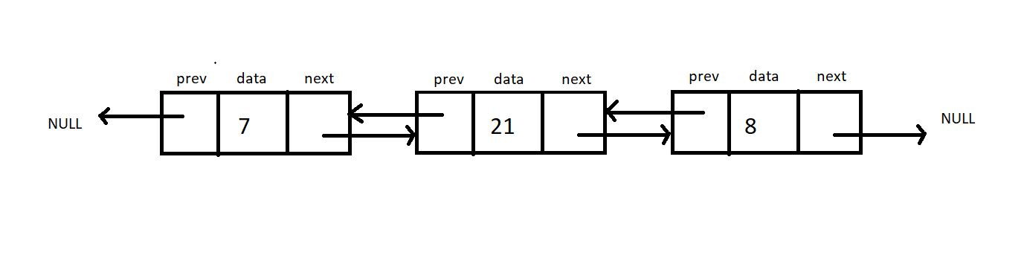

##### **How is it different from a singly linked list?**

* A doubly linked list allows traversal in both directions. We have the addresses of both the next node and the previous node. So, at any node, we’ll have the freedom to choose between going right or left.
* A node comprises three parts, the data, a pointer to the next node, and a pointer to the previous node.
* Head node has the pointer to the previous node pointing to NULL.

**Implementation in C:**

Let’s try implementing a doubly linked list in our codes. We’ll have a struct Node as before. The only information added to this struct Node is a struct Node* pointer to the previous node. Let’s name this prev.

This new information makes us travel in both directions, but using it follows the use of more memory space for a single node that now comprises three members. It is because of this we have a singly linked list.

struct Node {

int data;

Struct Node* next;

Struct Node* prev;

};

***Code Snippet 1: Implementation of a doubly linked list.***

#### Operations on a Doubly Linked List:

The insertion and deletion on a doubly linked list can be performed by recurring pointer connections, just like we saw in a singly linked list.

The difference here lies in the fact that we need to adjust two-pointers (prev and next) instead of one (next) in the case of a doubly linked list. It very much follows the fact, “With great power, comes great responsibility.” :)

#### Code as described:

#include<stdio.h>

#include<stdlib.h>

struct Node

{

int data;

struct Node *next;

};

void linkedListTraversal(struct Node *head){

struct Node *ptr = head;

do{

printf("Element is %d\n", ptr->data);

ptr = ptr->next;

}while(ptr!=head);

}

struct Node * insertAtFirst(struct Node *head, int data){

struct Node * ptr = (struct Node *) malloc(sizeof(struct Node));

ptr->data = data;

struct Node * p = head->next;

while(p->next != head){

p = p->next;

}

// At this point p points to the last node of this circular linked list

p->next = ptr;

ptr->next = head;

head = ptr;

return head;

}

int main(){

struct Node *head;

struct Node *second;

struct Node *third;

struct Node *fourth;

// Allocate memory for nodes in the linked list in Heap

head = (struct Node *)malloc(sizeof(struct Node));

second = (struct Node *)malloc(sizeof(struct Node));

third = (struct Node *)malloc(sizeof(struct Node));

fourth = (struct Node *)malloc(sizeof(struct Node));

// Link first and second nodes

head->data = 4;

head->next = second;

// Link second and third nodes

second->data = 3;

second->next = third;

// Link third and fourth nodes

third->data = 6;

third->next = fourth;

// Terminate the list at the third node

fourth->data = 1;

fourth->next = head;

printf("Circular Linked list before insertion\n");

linkedListTraversal(head);

head = insertAtFirst(head, 54);

head = insertAtFirst(head, 58);

head = insertAtFirst(head, 59);

printf("Circular Linked list after insertion\n");

linkedListTraversal(head);

return 0;

}

**Task:**Try implementing a traversal algorithm to traverse once to the right and once to the left. Print the data in both cases.

So this was all we had in linked lists. It was a great segment. Let’s give it an end here. We have so many things coming. So don’t miss out on this ever. Keep revising things at regular intervals.

# Introduction to Stack in Data Structures

It has been a while since we started this DSA course. We saw array ADT, linked lists and their variants, their implementation, and their operations. From this tutorial on, we will start learning about stack data structures.

#### Introduction:

A stack is a linear data structure. Any operation on the stack is performed in LIFO (Last In First Out) order. This means the element to enter the container last would be the first one to leave the container. It is imperative that elements above an element in a stack must be removed first before fetching any element.

An element can be pushed in this basket-type container illustrated below. Any basket has a limit, and so does our container too. Elements in a stack can only be pushed to a limit. And this extra pushing of elements in a stack leads to stack overflow.

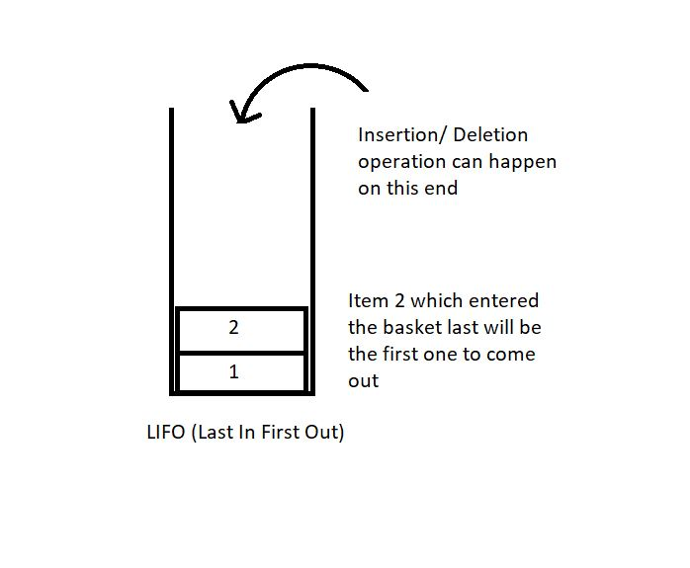

Applications of Stack:

1. We have talked about function calls before as well. A function until it returns reserves a space in the memory stack. Any function embedded in some function comes above the parent function in the stack. So, first, the embedded function ends, and then the parent one. Here, the function called last ends first.  (LIFO).
2. Infix to postfix conversion (and other similar conversions) will be dealt with in the coming tutorials.
3. Parenthesis matching and many more...

#### Stack ADT:

In order to create a stack, we need a pointer to the topmost element to gain knowledge about the element which is on the top so that any operation can be carried about. Along with that, we need the space for the other elements to get in and their data.

Here are some of the basic operations we would want to perform on stacks:

1. push(): to push an element into the stack
2. pop(): to remove the topmost element from the stack  
   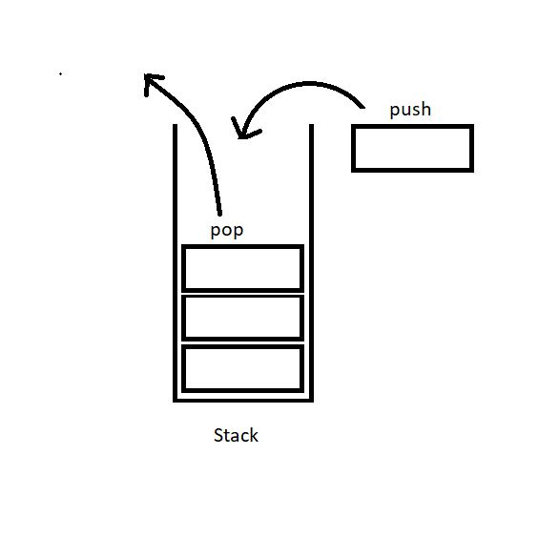
3. peek(index): to return the value at a given index
4. isempty() / isfull() : to determine whether the stack is empty or full to carry efficient push and pull operations.

#### Implementation:

A stack element can be implemented by both an array and a linked list. We’ll see both these methods in the coming tutorials.

A stack is a collection of elements with certain operations following the LIFO (Last in First Out) discipline.

# Implementing Stack Using Array in Data Structures

In the last tutorial, we learned about the stack data structure and its applications in several programming phases. We also discussed some of the operations possible on a stack. Today, we’ll try to implement these ideas on a stack using arrays. Although we have another choice of linked lists.

If you remember, a stack is a collection of elements following LIFO(Last In First Out); the element that gets pushed the last is the first one to come out of the stack.

#### Stack Using an Array

If we recall, arrays are linear data structures whose elements are indexed, and the elements can be accessed in constant time with their index. To implement a stack using an array, we’ll maintain a variable that will store the index of the top element.

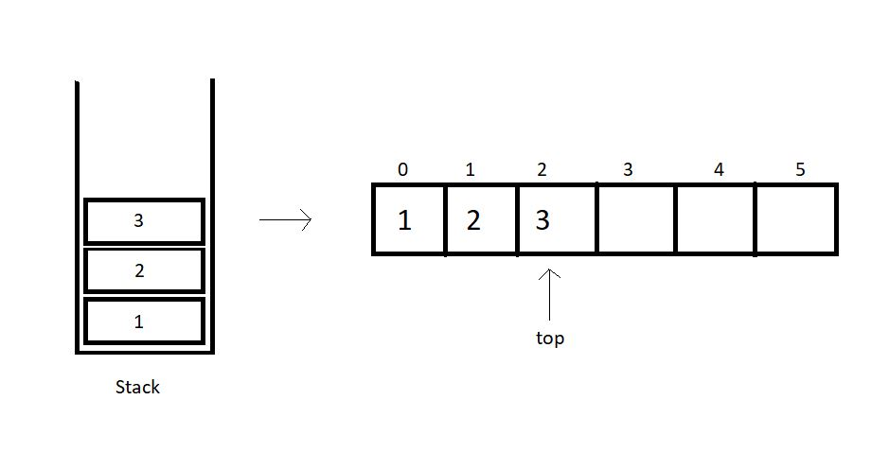

So, basically, we have few things to keep in check when we implement stacks using arrays.

**1. A fixed-size array.**This size can even be bigger than the size of the stack we are trying to implement, to stay on the safe side.

**2. An integer variable to store the index of the top element**, or the last element we entered in the array. This value is -1 when there is no element in the array.

We will try constructing a structure to embed all these functionalities. Let’s see how.

struct stack{

int size;

int top;

int* arr;

}

So, the struct above includes as its members, the size of the array, the index of the top element, and the pointer to the array we will make.

To use this struct,

1. You will just have to declare a struct stack
2. Set its top element to -1.
3. Furthermore, you will have to reserve memory in the heap using malloc.

Follow the example below for defining a stack:

struct stack S;

S.size = 80;

S.top = -1;

S.arr = (int*)malloc(S.size*sizeof(int));

We have used an integer array above, although it is just for the sake of simplicity. You have the freedom to customize your data types according to your needs.

We can now move on implementing the stack ADT, particularly their operators. We have in the list, push and pull, peek, and isempty/full operation. Let’s visit them one by one.

**push():**

By pushing, we mean inserting an element at the top of the stack. While using the arrays, we have the index to the top element of the array. So, we’ll just insert the new element at the index (top+1) and increase the top by 1. This operation takes a constant time, O(1). It’s intuitive to note that this operation is valid until (top+1) is a valid index and the array has an empty space.

**pop():**

Pop means to remove the last element entered in the stack, and that element has the index top. So, this becomes an easy job. We’ll just have to decrease the value of the top by 1, and we are done. The popped element can even be used in any way we like.

**C Code For Implementing Stack Using Array in Data Structures**

In the last tutorial, we covered how to implement stacks by using arrays. We also dealt with the basic structure behind defining a stack with all the customizations. We also learned about some of the operations one could do while handling stacks. Today, we’ll try implementing stacks using arrays in C.

I’ve attached the snippet below. Keeping that in mind will help you understand the implementation.

**Understanding the code snippet 1:**

1. So, the first thing would be to create the struct *Stack*we discussed in the previous tutorial. Include three members, an integer variable to store the size of the stack, an integer variable to store the index of the topmost element, and an integer pointer to hold the address of the array.

struct stack

{

int size;

int top;

int *arr;

};

Code Snippet 1: Creating stack

2. In *main,*create a struct stack *s,*and assign a value 80(you can assign any value of your choice) to its size, -1 to its top, and reserve memory in heap using malloc for its pointer *arr.*Don’t forget to include <stdlib> .

3. We have one more method to declare these stacks. We can define a struct stack pointer *s,*and use the arrow operators to deal with their members. The advantage of this method is that we can pass these pointers as references into functions very conveniently.

4. Before we advance to pushing elements in this stack, there are a few conditions to deal with. We can only push an element in this stack if there is some space left or the top is not equal to the last index. Similarly, we can only pop an element from this stack if some element is stored or the top is not equal to -1.

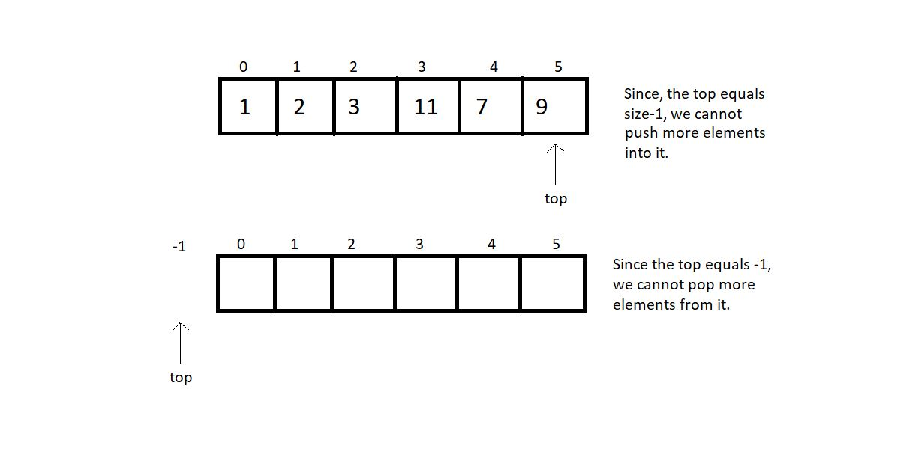

5. So, let us first write functions to check whether these stacks are empty or full.

6. Create an integer function *isEmpty,*and pass the pointer to the stack as a parameter. In the function, check if the top is equal to -1. If yes, then it’s empty and returns 1; otherwise, return 0.

int isEmpty(struct stack *ptr)

{

if (ptr->top == -1){

return 1;

}

else{

return 0;

}

}

***Code Snippet 2: Implementing isEmpty***

7. Create an integer function *isFull,*and pass the pointer to the stack as a parameter. In the function, check if the top is equal to (size-1). If yes, then it’s full and returns 1; otherwise, return 0.

int isFull(struct stack *ptr)

{

if (ptr->top == ptr->size - 1)

{

return 1;

}

else

{

return 0;

}

}

***Code Snippet 3: Implementing isFull***

**Here is the whole Source Code:**

#include <stdio.h>

#include <stdlib.h>

struct stack

{

int size;

int top;

int *arr;

};

int isEmpty(struct stack *ptr)

{

if (ptr->top == -1)

{

return 1;

}

else

{

return 0;

}

}

int isFull(struct stack *ptr)

{

if (ptr->top == ptr->size - 1)

{

return 1;

}

else

{

return 0;

}

}

int main()

{

// struct stack s;

// s.size = 80;

// s.top = -1;

// s.arr = (int *) malloc(s.size * sizeof(int));

struct stack *s;

s->size = 80;

s->top = -1;

s->arr = (int *)malloc(s->size * sizeof(int));

return 0;

}

***Code Snippet 4: Implementing isEmpty and  isFull***

Since there is no element inside the stack, we can now check if it’s empty.

// Check if stack is empty

if(isEmpty(s)){

printf("The stack is empty");

}

else{

printf("The stack is not empty");

}

***Code Snippet 5: Calling the function isEmpty***

Output:

The stack is empty

PS D:\MyData\Business\code playground\Ds & Algo with Notes\Code>

**Figure 1: Output of the above program**

So, yes, that worked fine. Now, we can easily push some elements inside this stack manually to test this *isEmpty* function. This should not be a tough job. Just insert an element at top+1 and increment top by 1.

// Pushing an element manually

s->arr[0] = 7;

s->top++;

// Check if stack is empty

if(isEmpty(s)){

printf("The stack is empty");

}

else{

printf("The stack is not empty");

}

***Code Snippet 6: Inserting an element in the stack***

Output after inserting an element:

The stack is not empty

PS D:\MyData\Business\code playground\Ds & Algo with Notes\Code>

**Figure 2: Output of the above program**

# Push, Pop and Other Operations in Stack Implemented Using an Array

We had already finished the basics of a stack, and its implementation using arrays. We have gained enough confidence by writing the codes for implementing stacks using arrays in C. Now we can learn about the operations one can perform on a stack while executing them using arrays.

We concluded our last tutorial with two of the most important points:

1. One cannot push more elements into a full-stack.
2. One cannot pop any more elements from an empty stack.



Declaring a stack was done in the last tutorial as well. Let's keep that in mind as we proceed.

**Operation 1: Push-**

1. The first thing is to define a stack. Suppose we have the creating stack and declaring its fundamentals part done, then pushing an element requires you to first check if there is any space left in the stack.

2. Call the isFull function which we did in the previous tutorial. If it’s full, then we cannot push anymore elements. This is the case of stack overflow. Otherwise, increase the variable top by 1 and insert the element at the index top of the stack.

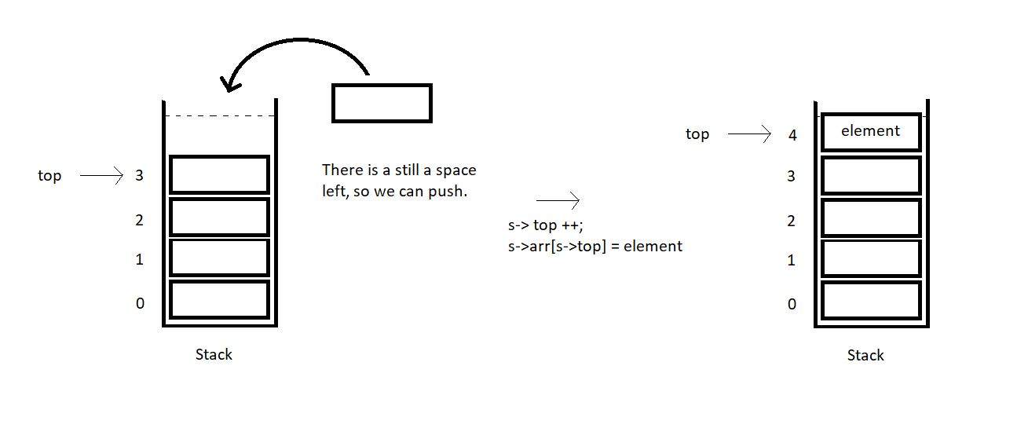

3. So, this is how we push an element in a stack array. Suppose we have an element x to insert in a stack array of size 4. We first checked if it was full, and found it was not full. We retrieved its top which was 3 here. We made it 4 by increasing it once. Now, just insert the element x at index 4, and we are done.

**Operation 2: Pop-**

Popping an element is very similar to inserting an element. You should first give it a try yourself. There are very subtle changes.

1. The first thing again is to define a stack. Get over with all the fundamentals. You must have learnt that by now. Then popping an element requires you to first check if there is any element left in the stack to pop.

2. Call the isEmpty function which we practiced in the previous tutorial. If it’s empty, then we cannot pop any element, since there is none left. This is the case of stack underflow. Otherwise, store the topmost element in a temporary variable. Decrease the variable top by 1 and return the temporary variable which stored the popped element.

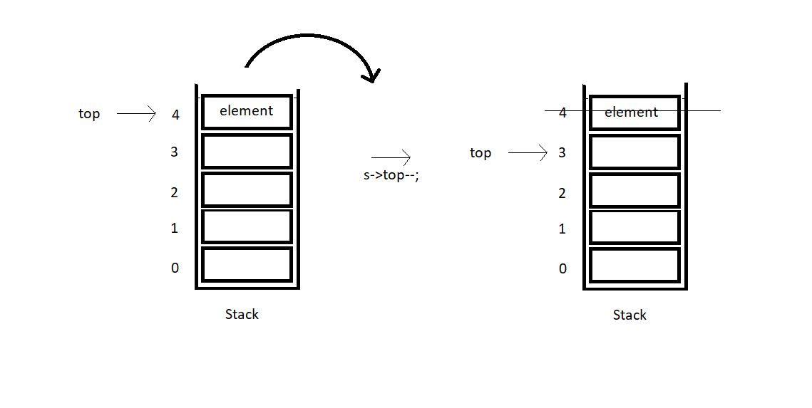

3. So, this is how we pop an element from a stack array. Suppose we make a pop call in a stack array of size 4. We first checked if it was empty, and found it was not empty. We retrieved its top which was 4 here. Stored the element at 4. We made it 3 by decreasing it once. Now, just return the element x, and popping is done.

# Coding Push(), Pop(), isEmpty() and isFull() Operations in Stack Using an Array| C Code For Stack

In the last tutorial, we covered the concepts behind the push and the pop operations on a stack implemented with an array. We saw how easy it is, to push an element in a non-full array, and to pop an element from a non-empty array. Today, we’ll be interested in coding these implementations in C.

If you didn't follow me in the last tutorial, I would recommend visiting that first. Because it not only covered the concepts but the implementation part as well. I have attached the code snippet below. Refer to it while we learn to code:

**Understanding the code snippet 1:**

1. There is nothing new now. You can just construct a struct stack, with all its three members, size, to store the size of the array used to handle this stack, top, to store the index of the topmost element in the stack and arr, a pointer to store the address of the array used. I will skip over this because we have done it before.

struct stack{

int size ;

int top;

int * arr;

};

**Code Snippet 1: Creating stack struct**

2. In the main, define a struct stack pointer sp, which will store the address of the stack. Since we are using malloc to reserve the memory in heap for this stack, don't forget to include the header file <stdlib.h>.

3. Initialize all the elements of the stack with some values.

4. Create the integer functions isFull and isEmpty. We have covered them in detail [here](https://www.codewithharry.com/videos/data-structures-and-algorithms-in-hindi-24). These functions are a must, while we use the push or the pop operations.

5. Create a void function push, and pass into it the address of the stack using the pointer sp and the value which is to be pushed.

6. Don’t forget to first check if our stack still has some space left to push elements. Use isFull function for that. If it returns 1, this is the case of stack overflow, otherwise, increase the top element of the stack by 1, and insert the value at this new top of the array.



void push(struct stack* ptr, int val){

if(isFull(ptr)){

printf("Stack Overflow! Cannot push %d to the stack\n", val);

}

else{

ptr->top++;

ptr->arr[ptr->top] = val;

}

}

Copy

**Code Snippet 2: Implementing the push operation.**

7. Create another void function pop, and pass into it the same address of the stack using the pointer sp. This is the only parameter since the pop operation pops only the topmost element.

8. Don’t forget to first check if our stack still has some elements left to pop elements. Use isEmpty function for that. If it returns 1, this is the case of stack underflow, otherwise, just decrease the top element of stack by 1, and we are done. The next time we push an element, we’ll overwrite the present element at that index. So, that’s basically ignored and acts as if it got deleted.



int pop(struct stack* ptr){

if(isEmpty(ptr)){

printf("Stack Underflow! Cannot pop from the stack\n");

return -1;

}

else{

int val = ptr->arr[ptr->top];

ptr->top--;

return val;

}

}

**Code Snippet 3: Implementing the pop operation.**

**Here is the whole source code:**

#include<stdio.h>

#include<stdlib.h>

struct stack{

int size ;

int top;

int * arr;

};

int isEmpty(struct stack* ptr){

if(ptr->top == -1){

return 1;

}

else{

return 0;

}

}

int isFull(struct stack* ptr){

if(ptr->top == ptr->size - 1){

return 1;

}

else{

return 0;

}

}

void push(struct stack* ptr, int val){

if(isFull(ptr)){

printf("Stack Overflow! Cannot push %d to the stack\n", val);

}

else{

ptr->top++;

ptr->arr[ptr->top] = val;

}

}

int pop(struct stack* ptr){

if(isEmpty(ptr)){

printf("Stack Underflow! Cannot pop from the stack\n");

return -1;

}

else{

int val = ptr->arr[ptr->top];

ptr->top--;

return val;

}

}

int main(){

struct stack *sp = (struct stack *) malloc(sizeof(struct stack));

sp->size = 10;

sp->top = -1;

sp->arr = (int *) malloc(sp->size * sizeof(int));

printf("Stack has been created successfully\n");

return 0;

}

**Code Snippet 4: Implementing the pop and the push operations.**

Now let's check if everything is working properly. We’ll first check if the isFull and the isEmpty functions work. Call these functions after declaring the stack sp.

printf("Before pushing, Full: %d\n", isFull(sp));

printf("Before pushing, Empty: %d\n", isEmpty(sp));

**Code Snippet 5:  Calling the isEmpty and the isFull functions**

The output we received, was:

0

1

PS D:\MyData\Business\code playground\Ds & Algo with Notes\Code>

**Figure 1: Output of the above program**

So, since the stack is empty, it returned 1. Now, let’s push 10 elements into this stack array using the push function. And then call the isFull and the isEmpty functions.

push(sp, 1);

push(sp, 23);

push(sp, 99);

push(sp, 75);

push(sp, 3);

push(sp, 64);

push(sp, 57);

push(sp, 46);

push(sp, 89);

push(sp, 6); // ---> Pushed 10 values

// push(sp, 46); // Stack Overflow since the size of the stack is 10

printf("After pushing, Full: %d\n", isFull(sp));

printf("After pushing, Empty: %d\n", isEmpty(sp));

**Code Snippet 6:  Using the push function**

The output we received, was:

1

0

PS D:\MyData\Business\code playground\Ds & Algo with Notes\Code>

**Figure 2: Output of the above program**

Since the stack is now full, it returned 1 from isFull function. This means our push function is working well. Now, let’s pop some elements.

printf("Popped %d from the stack\n", pop(sp)); // --> Last in first out!

printf("Popped %d from the stack\n", pop(sp)); // --> Last in first out!

printf("Popped %d from the stack\n", pop(sp)); // --> Last in first out!

**Code Snippet 7:  Using the pop function**

The output we received was:

Popped 6 from the stack

Popped 89 from the stack

Popped 46 from the stack

PS D:\MyData\Business\code playground\Ds & Algo with Notes\Code>

**Figure 3: Output of the above program**

**Peek Operation in Stack Using Arrays (With C Code & Explanation)**

Now that we've finished the push and pop operations, we'll move on to the peek operation in stacks. Peeking into something literally means to quickly see what’s there at someplace. In a similar way, it refers to looking for the element at a specific index in a stack.

If you could remember, pushing an element into a stack needs you to first check if the stack is not full, and then insert the element at the incremented value of the top. And similarly, popping from a stack, needs you to first check if it is not empty, and then you just decrease the value of the top by 1.

Peek operation requires the user to give a position to peek at as well. Here, position refers to the distance of the current index from the top element +1. I’ll make you visualize this via a few illustrations.

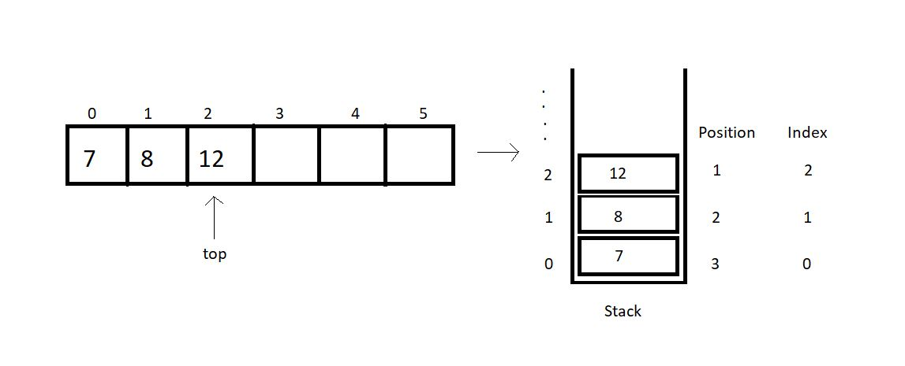

The index, mathematically, is (*top -position+1*).

So, before we return the element at the asked position, we’ll check if the position asked is valid for the current stack. Index 0, 1 and 2 are valid for the stack illustrated above, but index 4 or 5 or any other negative index is invalid.

Note: peek(1) returns 12 here.

Now, since we are done with all the basics of the peek operation, we can try writing its code as well. Here, we’ll focus mainly on the peek operation, so you can just copy the codes from the last tutorial, where we learned writing*push*and *pop, isFull*and *isEmpty.*

I have attached the snippet below for your reference.

**Understanding the code snippet 1:**

1. I hope you have copied everything from the last tutorial. That’ll save us some time. And this was important since we are focusing just on the peek operation.

2. Create an integer function *peek,*and pass the reference to the stack, and the position to peek in, as its parameters.

3. Inside the function, create an integer variable *arrayInd*which will store the index of the array to be returned. This is just (*top-position +1*).

4. Before we return anything, we’ll check if the *arrayInd*is a valid index. If it’s less than 0, it is invalid and we report an error. Otherwise,we just return the element at the index, (*top-position+1*).

int peek(struct stack* sp, int i){

int arrayInd = sp->top -i + 1;

if(arrayInd < 0){

printf("Not a valid position for the stack\n");

return -1;

}

else{

return sp->arr[arrayInd];

}

}

**Code Snippet 1: Writing the peek function**

**Here is the whole source code:**

#include<stdio.h>

#include<stdlib.h>

struct stack{

int size ;

int top;

int * arr;

};

int isEmpty(struct stack* ptr){

if(ptr->top == -1){

return 1;

}

else{

return 0;

}

}

int isFull(struct stack* ptr){

if(ptr->top == ptr->size - 1){

return 1;

}

else{

return 0;

}

}

void push(struct stack* ptr, int val){

if(isFull(ptr)){

printf("Stack Overflow! Cannot push %d to the stack\n", val);

}

else{

ptr->top++;

ptr->arr[ptr->top] = val;

}

}

int pop(struct stack* ptr){

if(isEmpty(ptr)){

printf("Stack Underflow! Cannot pop from the stack\n");

return -1;

}

else{

int val = ptr->arr[ptr->top];

ptr->top--;

return val;

}

}

int peek(struct stack* sp, int i){

int arrayInd = sp->top -i + 1;

if(arrayInd < 0){

printf("Not a valid position for the stack\n");

return -1;

}

else{

return sp->arr[arrayInd];

}

}

int main(){

struct stack *sp = (struct stack *) malloc(sizeof(struct stack));

sp->size = 50;

sp->top = -1;

sp->arr = (int *) malloc(sp->size * sizeof(int));

printf("Stack has been created successfully\n");

printf("Before pushing, Full: %d\n", isFull(sp));

printf("Before pushing, Empty: %d\n", isEmpty(sp));

return 0;

}

**Code Snippet 2: Implementing the peek function**

This is how we peek into a stack array. We’ll see how properly the functions work. First, we’ll push a few elements into the empty stack we created.

push(sp, 1);

push(sp, 23);

push(sp, 99);

push(sp, 75);

push(sp, 3);

push(sp, 64);

push(sp, 57);

push(sp, 46);

push(sp, 89);

push(sp, 6);

push(sp, 5);

push(sp, 75);

**Code Snippet 3: Pushing a few elements in the stack**

Now, we can peek into this stack array and print all the elements using a loop.

// Printing values from the stack

for (int j = 1; j <= sp->top + 1; j++)

{

printf("The value at position %d is %d\n", j, peek(sp, j));

}

**Code Snippet 4: Calling the peek function**

The output we received was:

The value at position 1 is 75

The value at position 2 is 5

The value at position 3 is 6

The value at position 4 is 89

The value at position 5 is 46

The value at position 6 is 57

The value at position 7 is 64

The value at position 8 is 3

The value at position 9 is 75

The value at position 10 is 99

The value at position 11 is 23

The value at position 12 is 1

PS D:\MyData\Business\code playground\Ds & Algo with Notes\Code>

**Figure 1: Output of the above program**

# stackTop, stackBottom & Time Complexity of Operations in Stack Using Arrays

In the last tutorial, we talked about the peek operation and implemented it in C using arrays. Today, we will explore some new stack operations.

Take a deep breath of relief since the things we are discussing today are the easiest of all. We will first start by learning about two operations we have in stacks, stackTop and stackBottom.

Let’s consider a stack array for the understanding purpose.

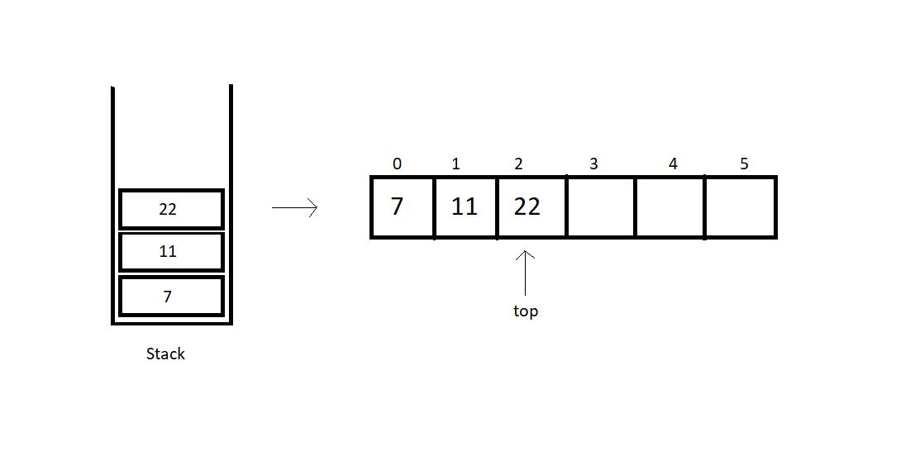

**stackTop:**

This operation is responsible for returning the topmost element in a stack. Retrieving the topmost element was never a big deal. We can just use the stack member top to fetch the topmost index and its corresponding element. Here, in the illustration above, we have the top member at index 2. So, the stackTop operation shall return the value 22.

**stackBottom:**

This operation is responsible for returning the bottommost element in a stack, which intuitively, is the element at index 0. We can just fetch the bottommost index, which is 0, and return the corresponding element. Here, in the illustration above, we have the bottommost element at index 0. So, the stackBottom operation shall return the value 7.

One thing one must observe here is that both these operations happen to work in a constant runtime, that is O(1). Because we are just accessing an element at an index, and that works in a constant time in an array.

**Time complexities of other operations:**

* **isEmpty():**This operation just checks if the top member equals -1. This works in a constant time, hence, O(1).
* **isFull():**This operation just checks if the top member equals size -1. Even this works in a constant time, hence, O(1).
* **push():**Pushing an element in a stack needs you to just increase the value of top by 1 and insert the element at the index. This is again a case of O(1).
* **pop():**Popping an element in a stack needs you to just decrease the value of top by 1 and return the element we ignored. This is again a case of O(1).
* **peek():**Peeking at a position just returns the element at the index, (top - position + 1), which happens to work in a constant time. So, even this is an example of O(1).

So, basically all the operations we discussed follow a constant time complexity.

**Implementation:**

I would suggest you all implement them on your own before moving ahead. I have attached the snippet below, for your referral.

**Understanding the snippet below:**

1. First of all, copy everything we have covered up to this point in your IDEs. I don’t want to repeat them all and make this lengthy.

2. I suppose you have all the functions and declarations done.

3. Create an integer function stackTop, and pass the reference to the stack you created as a parameter. Just return the element at the index top of the array. And that’s it.

int stackTop(struct stack* sp){

return sp->arr[sp->top];

}

**Code Snippet 1: Implementing stackTop**

4. Create an integer function stackBottom, and pass the reference to the stack you created as a parameter. And then return the element at the index 0 of the array.

int stackBottom(struct stack* sp){

return sp->arr[0];

}

**Code Snippet 2: Implementing stackBottom**

**Here is the whole source code:**

#include<stdio.h>

#include<stdlib.h>

struct stack{

int size ;

int top;

int * arr;

};

int isEmpty(struct stack* ptr){

if(ptr->top == -1){

return 1;

}

else{

return 0;

}

}

int isFull(struct stack* ptr){

if(ptr->top == ptr->size - 1){

return 1;

}

else{

return 0;

}

}

void push(struct stack* ptr, int val){

if(isFull(ptr)){

printf("Stack Overflow! Cannot push %d to the stack\n", val);

}

else{

ptr->top++;

ptr->arr[ptr->top] = val;

}

}

int pop(struct stack* ptr){

if(isEmpty(ptr)){

printf("Stack Underflow! Cannot pop from the stack\n");

return -1;

}

else{

int val = ptr->arr[ptr->top];

ptr->top--;

return val;

}

}

int peek(struct stack* sp, int i){

int arrayInd = sp->top -i + 1;

if(arrayInd < 0){

printf("Not a valid position for the stack\n");

return -1;

}

else{

return sp->arr[arrayInd];

}

}

int stackTop(struct stack* sp){

return sp->arr[sp->top];

}

int stackBottom(struct stack* sp){

return sp->arr[0];

}

int main(){

struct stack *sp = (struct stack *) malloc(sizeof(struct stack));

sp->size = 50;

sp->top = -1;

sp->arr = (int *) malloc(sp->size * sizeof(int));

printf("Stack has been created successfully\n");

printf("Before pushing, Full: %d\n", isFull(sp));

printf("Before pushing, Empty: %d\n", isEmpty(sp));

push(sp, 1);

push(sp, 23);

push(sp, 99);

push(sp, 75);

push(sp, 3);

push(sp, 64);

push(sp, 57);

push(sp, 46);

push(sp, 89);

push(sp, 6);

push(sp, 5);

push(sp, 75);

// // Printing values from the stack

// for (int j = 1; j <= sp->top + 1; j++)

// {

// printf("The value at position %d is %d\n", j, peek(sp, j));

// }

return 0;

}

**Code Snippet 3: Implementing stackTop & stackBottom**

Now, since we have done pushing elements into the stack, we can call our functions, stackTop and stackBottom.

printf("The top most value of this stack is %d\n", stackTop(sp));

printf("The bottom most value of this stack is %d\n", stackBottom(sp));

**Code Snippet 4: Calling functions stackTop & stackBottom**

And the output we received was:

The top most value of this stack is 75

The bottom most value of this stack is 1

PS D:\MyData\Business\code playground\Ds & Algo with Notes\Code>

**Figure 1: Output of the above program**

Finally, I can say that it is all that we had when we implemented stacks using arrays.

# How to Implement Stack Using Linked List?

Earlier before, whenever we discussed stacks, we used arrays. We saw how good an array is while implementing stacks using them. We saw it follows constant time complexity for each of the operations we discussed. Today, we’ll begin implementing stacks using a different data structure, linked lists.

Linked-lists is surely not a new term for you all. We have come here only after discussing all the basics. So, if you haven’t come across the linked lists, you must have skipped them. I highly recommend you all to go through the videos discussing them in the playlist. Assuming you are done, we’ll proceed.

**Implementing stacks using linked lists:**

We can now consider a singly linked list. Follow the illustration below.

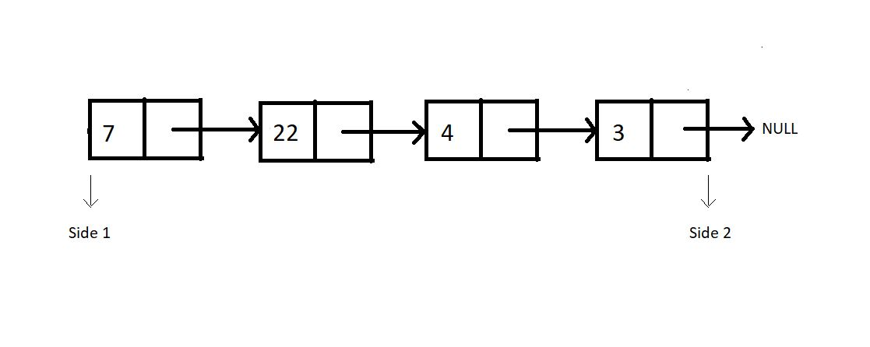

Consider this linked list functioning as a stack. And as you know, we have two sides of a linked list, one the head, and the other pointing to NULL. Which side do you feel should we consider as the top of the stack, where we push and pop from? After following me all the way through here, you would say the head side.

**And why the head side, that is side 1?**

Because that’s the head node of the linked list, and insertion and deletion of a node at head happens to function in a constant time complexity, O(1). Whereas inserting or deleting a node at the last position takes a linear time complexity, O(n).

So that stack equivalent of the above illustrated linked list looks something like this:

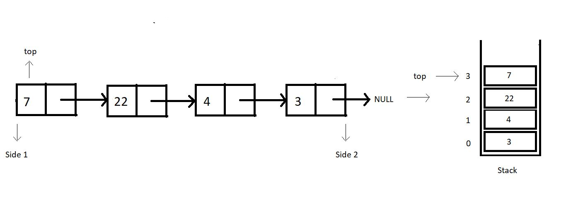

Let’s revise how we used to define a struct Node in linked lists. We had a struct, and two structure members, data and a struct Node pointer to store the address of the next node.

struct Node{

int data;

struct Node* next;

}

**Code Snippet 1: Structure of a Node in a Linked List**

**When is our stack empty or full?**

Stacks when implemented with linked lists never get full. We can always add a node to it. There is no limit on the number of nodes a linked list can contain until we have some space in heap memory. Whereas stacks become empty when there is no node in the linked list, hence when the top equals to NULL.

1. Condition for stack full: When heap memory is exhausted
2. Condition for stack empty:  top == NULL

One change I would like to implement before we proceed; the head node we had in linked lists, is the top for our stacks now. So, from now on, the head node will be referred to as the top node.

Even though a stack-linked list has no upper limit to its size, you can always set a custom size for it.

# Implementing all the Stack Operations using Linked List (With Code in C)

In the last tutorial, we started learning about implementing stacks using linked lists. We saw the benefits of using the head side of the linked list as the stack top. We figured out the conditions for the stack linked lists to be empty or full. Today, we’ll discuss more of these operations, and write their codes in C.

Before writing the codes, we must discuss the algorithm we’ll put into operations. Let's go through them one by one.

**1. isEmpty :**It just checks if our top element is NULL.

**2. isFull :**A stack is full, only if no more nodes are being created using malloc. This is the condition where heap memory gets exhausted.

**3. Push :**The first thing we need before pushing an element is to create a new node. Check if the stack is not already full. Now, we follow the same concept we learnt while inserting an element at the head or at the index 0 in a linked list. Just set the address of the current top in the next member of the new node, and update the top element with this new node.

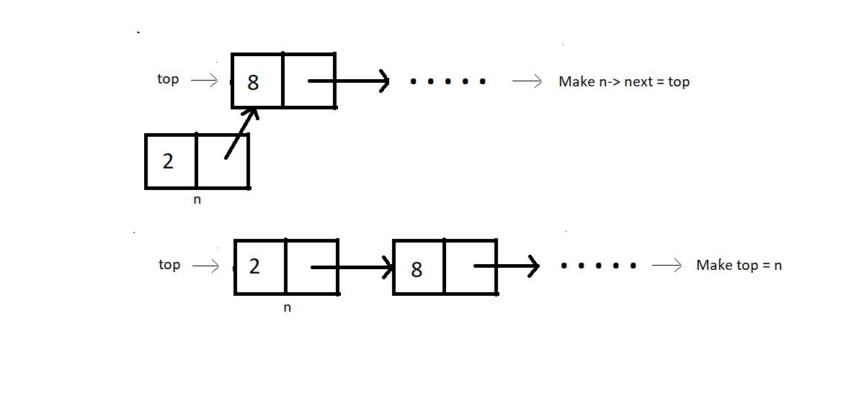

**4. Pop :**First thing is to check if the stack is not already empty Now, we follow the same concept we learnt while deleting an element at the head or at the index 0 in a linked list. Just update the top pointer with the next node, skipping the current top.

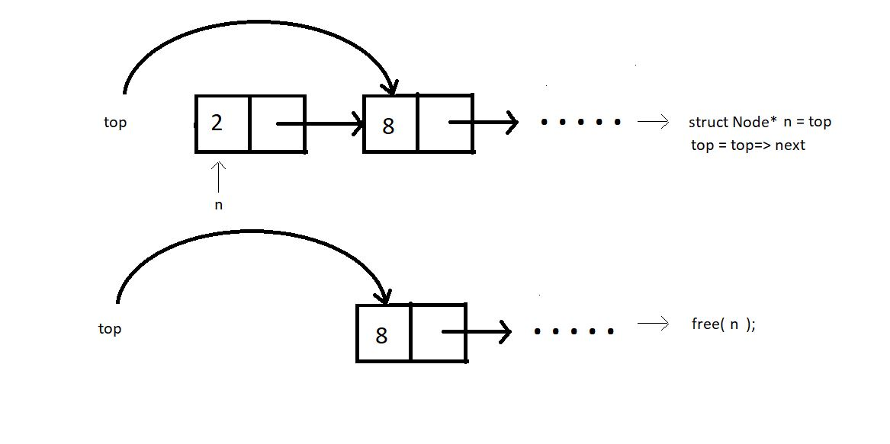

We’ll limit ourselves to these four operations for today. We’ll now move to our editors to code them. We have already covered the tough parts of today's tutorial; these are the easy ones remaining. I have attached the code snippet below, refer to them while you code:

**Understanding the code snippet below:**

1. Create the structure for nodes. We’ll use struct in C, name its Node, and make two members of this struct; an integer variable to store the data, and a struct Node pointer to store the address of the next element.

2. First of all, we’ll create the isEmpty and the isFull functions.

**3. isEmpty():**

* Create an integer function isEmpty, and pass the pointer to the top node as the parameter. If this top node equals NULL, return 1, else 0.

int isEmpty(struct Node* top){

if (top==NULL){

return 1;

}

else{

return 0;

}

}

**Code Snippet 1: Implementing isEmpty function**

**4. isFull():**

* Create an integer function isFull, and pass the pointer to the top node as the parameter.
* Create a new struct Node* pointer p, and assign it a new memory location in the heap. If this newly created node p is NULL, return 1, else 0.

int isFull(struct Node* top){

struct Node* p = (struct Node*)malloc(sizeof(struct Node));

if(p==NULL){

return 1;

}

else{

return 0;

}

}

**Code Snippet 2: Implementing isFull function**

**5. Push():**

* Create a struct Node* function push which will return the pointer to the new top node.
* We’ll pass the current top pointer and the data to push in the stack, in the function.
* Check if the stack is already not full, if full, return the condition stack overflow.
* Create a new struct Node* pointer n, and assign it a new memory location in the heap.
* Assign top to the next member of the n structure using n-> next = top, and the given data to its data member.
* Return this pointer n, since this is our new top node.

struct Node* push(struct Node* top, int x){

if(isFull(top)){

printf("Stack Overflow\n");

}

else{

struct Node* n = (struct Node*) malloc(sizeof(struct Node));

n->data = x;

n->next = top;

top = n;

return top;

}

}

**Code Snippet 3: Implementing Push function**

**6. Pop() :**

* Create an integer function pop which will return the element we remove from the top.
* We’ll pass the reference of the current top pointer in the function. We are passing the reference this time, because we are not returning the updated top from the function.
* Check if the stack is already not empty, if empty, return the condition stack underflow.
* Create a new struct Node* pointer n, and make it point to the current top. Store the data of this node in an integer variable x.
* Assign top to the next member of the list, by top = top->next, because this is going to be our new top.
* Free the pointer n. And return x.

int pop(struct Node** top){

if(isEmpty(*top)){

printf("Stack Underflow\n");

}

else{

struct Node* n = *top;

*top = (*top)->next;

int x = n->data;

free(n);

return x;

}

}

**Code Snippet 4: Implementing pop function**

7. Now, since we would always need a traversal function to see if our operations are functioning all well, we’ll just bring our codes from the linked list tutorial, named linkedListTraversal.

void linkedListTraversal(struct Node *ptr)

{

while (ptr != NULL)

{

printf("Element: %d\n", ptr->data);

ptr = ptr->next;

}

}

**Code Snippet 5: LinkedListTraversal function**

**Here is the whole source code:**

#include<stdio.h>

#include<stdlib.h>

struct Node{

int data;

struct Node * next;

};

void linkedListTraversal(struct Node *ptr)

{

while (ptr != NULL)

{

printf("Element: %d\n", ptr->data);

ptr = ptr->next;

}

}

int isEmpty(struct Node* top){

if (top==NULL){

return 1;

}

else{

return 0;

}

}

int isFull(struct Node* top){

struct Node* p = (struct Node*)malloc(sizeof(struct Node));

if(p==NULL){

return 1;

}

else{

return 0;

}

}

struct Node* push(struct Node* top, int x){

if(isFull(top)){

printf("Stack Overflow\n");

}

else{

struct Node* n = (struct Node*) malloc(sizeof(struct Node));

n->data = x;

n->next = top;

top = n;

return top;

}

}

int pop(struct Node** top){

if(isEmpty(*top)){

printf("Stack Underflow\n");

}

else{

struct Node* n = *top;

*top = (*top)->next;

int x = n->data;

free(n);

return x;

}

}

int main(){

struct Node* top = NULL;

return 0;

}

**Code Snippet 6: Implementing a stack and its operations using linked list**

We have just created a stack using a linked list. We have assigned NULL to the top node. Let’s first push some elements and see if the changes reflect in the stack. We’ll use traversal for that.

top = push(top, 78);

top = push(top, 7);

top = push(top, 8);

linkedListTraversal(top);

**Code Snippet 7: Pushing elements in a stack.**

The output we received was:

Element: 8

Element: 7

Element: 78

PS D:\MyData\Business\code playground\Ds & Algo with Notes\Code>

**Figure 1: Output of the above program**

So, the push function worked all good. Let’s pop one element out from the stack. And then again traverse through it.

int element = pop(&top);

printf("Popped element is %d\n", element);

linkedListTraversal(top);

**Code Snippet 8: Popping elements from a stack.**

The output we received then was:

Popped element is 8

Element: 7

Element: 78

PS D:\MyData\Business\code playground\Ds & Algo with Notes\Code>

**Figure 2: Output of the above program**

You must have observed we used the pointer to a pointer while popping elements from the stack. We referenced and unreferenced twice. So, to avoid all these complexities, I still have a better way to implement that thing. We can declare the top pointer globally. Earlier we used to declare it under main. Declaring it globally gives its access to all our functions without passing them as a parameter.

Refer to the second implementation of stacks below. They are more or less the same, just subtle changes. Follow them carefully. You are wise enough to understand them on your own.

#include<stdio.h>

#include<stdlib.h>

struct Node{

int data;

struct Node * next;

};

struct Node* top = NULL;

void linkedListTraversal(struct Node *ptr)

{

while (ptr != NULL)

{

printf("Element: %d\n", ptr->data);

ptr = ptr->next;

}

}

int isEmpty(struct Node* top){

if (top==NULL){

return 1;

}

else{

return 0;

}

}

int isFull(struct Node* top){

struct Node* p = (struct Node*)malloc(sizeof(struct Node));

if(p==NULL){

return 1;

}

else{

return 0;

}

}

struct Node* push(struct Node* top, int x){

if(isFull(top)){

printf("Stack Overflow\n");

}

else{

struct Node* n = (struct Node*) malloc(sizeof(struct Node));

n->data = x;

n->next = top;

top = n;

return top;

}

}

int pop(struct Node* tp){

if(isEmpty(tp)){

printf("Stack Underflow\n");

}

else{

struct Node* n = tp;

top = (tp)->next;

int x = n->data;

free(n);

return x;

}

}

int main(){

top = push(top, 78);

top = push(top, 7);

top = push(top, 8);

// linkedListTraversal(top);

int element = pop(top);

printf("Popped element is %d\n", element);

linkedListTraversal(top);

return 0;

}

**Code Snippet 9: Implementing a stack and its operations using linked list**

# peek(), stackTop() and Other Operations on Stack Using Linked List (with C Code)

In the last tutorial, we learned to implement stacks using linked lists. We saw how efficiently we can push and pop elements in a stack-linked list. We saw a few other operations, isEmpty, isFull, traversal. Today, we will cover the remaining operations. They are: peek, stackTop, etc.

Similar to what we did last time, we will first understand the algorithm behind the operations, followed by the coding section. Let’s see them individually, but before that, let’s have an example illustration of the stack we’ll go into within today’s tutorial.

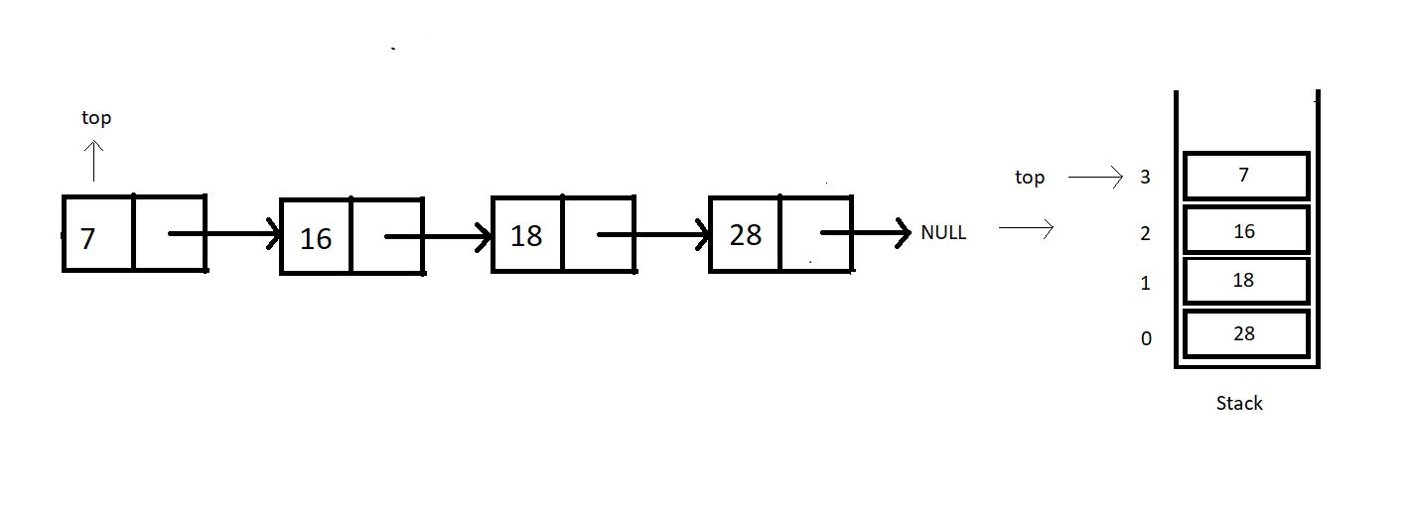

**1. peek:**This operation is meant to return the element at a given position. Do mind that the position of an element is not the same as the index of an element. In fact, there is nothing as an index in a linked list. Refer to the illustration below.

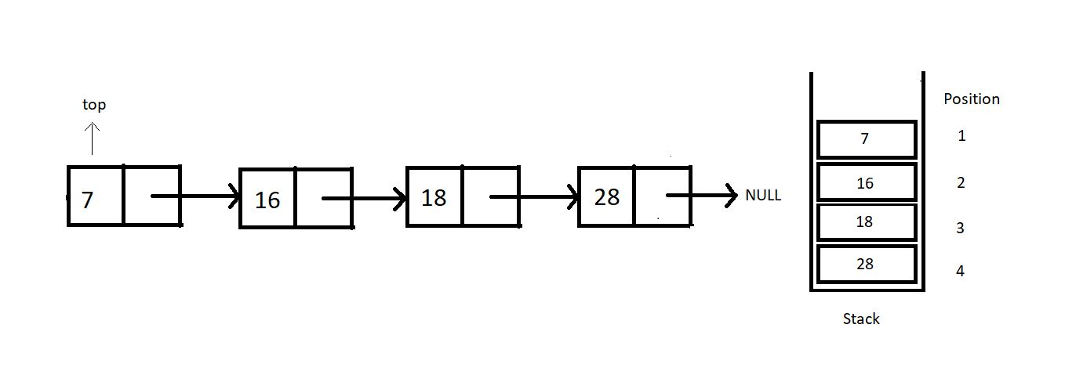

Peeking in a stack linked list is not as efficient as when we worked with arrays. Peeking in a linked list takes O(n) because it first traverses to the position where we want to peek in. So, we’ll just have to move to that node and return its data.

**2. stackTop:**This operation just returns the topmost value in the stack. That is, it just returns the data member of the top pointer.

**3. stackBottom:**

I will leave the last operation, stackBottom, for your homework. Try implementing this on your own, and let me know if you could. You should be able to code this since we have covered the concepts already in the stack arrays.

So, these were the only operations we had in mind to discuss with you all. You will come across several variations of these. Nevertheless, you are intelligent enough to be able to change your codes if necessary. We’ll now move to our editors to code the operations we discussed today. I have attached the code snippet below. Refer to them while you code:

**Understanding the code snippet below:**

1. Copy everything we did in the last tutorial. This will save us some time. It will also prevent repetitions in the course. Our main focus for today is to discuss these three operations. So, creating the stack and other operations can be ignored since they have already been covered.

2. We’ll start with the peek function.

**3. peek():**

* Create an integer function peek, and pass the position you want to peek in as a parameter.
* Since we have made the stack pointer global, we should not use that pointer to traverse; otherwise, we will lose the pointer to the top node. Rather create a new struct Node pointer ptr and give it the value of top.
* Run a loop from 0 to pos-1, since we are already at the first position.
* If our pointer reaches NULL at some point, we must have reached the last node, and the position asked was beyond the available positions, hence breaking the loop.
* If the current pointer found the position and it is not equal to NULL, return the data at that node, else -1.

int peek(int pos){

struct Node* ptr = top;

for (int i = 0; (i < pos-1 && ptr!=NULL); i++)

{

ptr = ptr->next;

}

if(ptr!=NULL){

return ptr->data;

}

else{

return -1;

}

}

***Code Snippet 1: Implementing peek function***

**4. stackTop():**

* Create an integer function stackTop, and we are no longer passing any parameter since the top pointer is declared globally.
* Simply return the data member of the struct Node pointer top, and that’s it.

int stackTop(){

return top->data;

}

***Code Snippet 2: Implementing stackTop function***

**Here is the whole source code:**

#include<stdio.h>

#include<stdlib.h>

struct Node{

int data;

struct Node * next;

};

struct Node* top = NULL;

void linkedListTraversal(struct Node *ptr)

{

while (ptr != NULL)

{

printf("Element: %d\n", ptr->data);

ptr = ptr->next;

}

}

int isEmpty(struct Node* top){

if (top==NULL){

return 1;

}

else{

return 0;

}

}

int isFull(struct Node* top){

struct Node* p = (struct Node*)malloc(sizeof(struct Node));

if(p==NULL){

return 1;

}

else{

return 0;

}

}

struct Node* push(struct Node* top, int x){

if(isFull(top)){

printf("Stack Overflow\n");

}

else{

struct Node* n = (struct Node*) malloc(sizeof(struct Node));

n->data = x;

n->next = top;

top = n;

return top;

}

}

int pop(struct Node* tp){

if(isEmpty(tp)){

printf("Stack Underflow\n");

}

else{

struct Node* n = tp;

top = (tp)->next;

int x = n->data;

free(n);

return x;

}

}

int peek(int pos){

struct Node* ptr = top;

for (int i = 0; (i < pos-1 && ptr!=NULL); i++)

{

ptr = ptr->next;

}

if(ptr!=NULL){

return ptr->data;

}

else{

return -1;

}

}

int main(){

top = push(top, 28);

top = push(top, 18);

top = push(top, 15);

top = push(top, 7);

linkedListTraversal(top);

for (int i = 1; i <= 4; i++)

{

printf("Value at position %d is : %d\n", i, peek(i));

}

return 0;

}

***Code Snippet 3: Using peek function***

Let’s now push some elements into the stack and see if the operations work all good.

top = push(top, 28);

top = push(top, 18);

top = push(top, 15);

top = push(top, 7);

***Code Snippet 4: Using push function to put some elements inside the stack***

Since we have pushed the elements, we can call our peek function in a loop, printing the whole array.

for (int i = 1; i <= 4; i++)

{

printf("Value at position %d is : %d\n", i, peek(i));

}

***Code Snippet 5: Using peek function to print the whole stack***

The output we received was:

Value at position 1 is : 7

Value at position 2 is : 15

Value at position 3 is : 18

Value at position 4 is : 28

PS D:\MyData\Business\code playground\Ds & Algo with Notes\Code>

***Figure 1: Output of the above program***

# Parenthesis Matching Problem Using Stack Data Structure (Applications of Stack)

I was very excited to bring this topic to your attention. Parenthesis matching is one of the basic applications of the stack we learned about in our last ten lectures. This will be thought-provoking to you all as well. Since the dawn of programming, parenthesis matching has been a favorite topic. It is a must learn. So, today, we’ll start learning about parenthesis matching and how it gets implemented using stacks.

Parenthesis matching has always been threatening to beginners. But realizing its implementation using stacks makes it very intuitive and easy to deal with.

#### What is parenthesis matching?

If you remember learning mathematics in school, we had BODMAS there, which required you to solve the expressions, first enclosed by brackets, and then the independent ones. That's the bracket we're referring to. We have to see if the given expression has balanced brackets which means every opening bracket must have a corresponding closing bracket and vice versa.

Below given illustrations would surely make it clear for you.

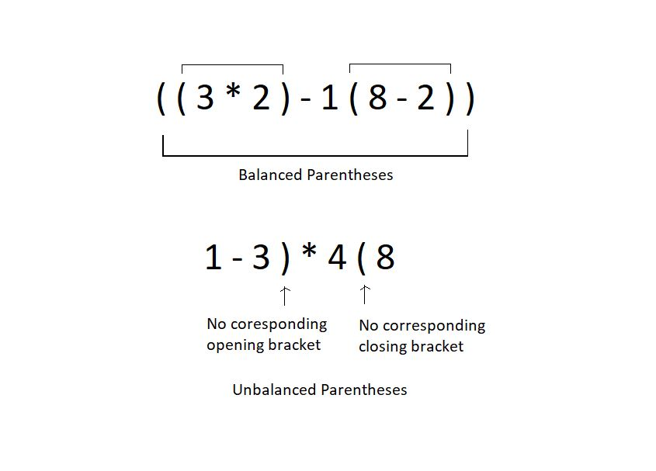

Checking if the parentheses are balanced or not must be a cakewalk for humans, since we have been dealing with this for the whole time. But even we would fail if the expression becomes too large with a great number of parentheses. This is where automating the process helps. And for automation, we need a proper working algorithm. We will see how we accomplish that together.

We’ll use stacks to match these parentheses. Let’s see how:

1. Assume the expression given to you as a character array.

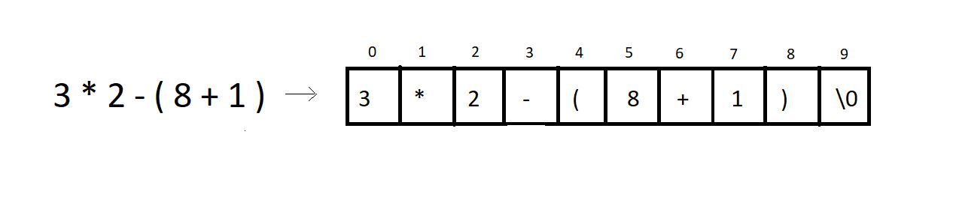

2. Iterate through the character array and ignore everything you find other than the opening and the closing parenthesis.  Every time you find an opening parenthesis, push it inside a character stack. And every time you find a closing parenthesis, pop from the stack, in which you pushed the opening bracket.

**3. Conditions for unbalanced parentheses:**

* When you find a closing parenthesis and try achieving the pop operation in the stack, the stack must not become underflow. To match the existing closing parenthesis, at least one opening bracket should be available to pop. If there is no opening bracket inside the stack to pop, we say the expression has unbalanced parentheses.
* For example: the expression **(2+3)*6)1+5**has no opening bracket corresponding to the last closing bracket. Hence unbalanced.
* At EOE, that is, when you reach the end of the expression, and there is still one or more opening brackets left in the stack, and it is not empty, we call these parentheses unbalanced.
* For example: the expression **(2+3)*6(1+5** has 1 opening bracket left in the stack even after reaching the EOE. Hence unbalanced.

**4. Note:** Counting and matching the opening and closing brackets numbers is not enough to conclude if the parentheses are balanced. For eg: **1+3)*6(6+2**.

**Example:**

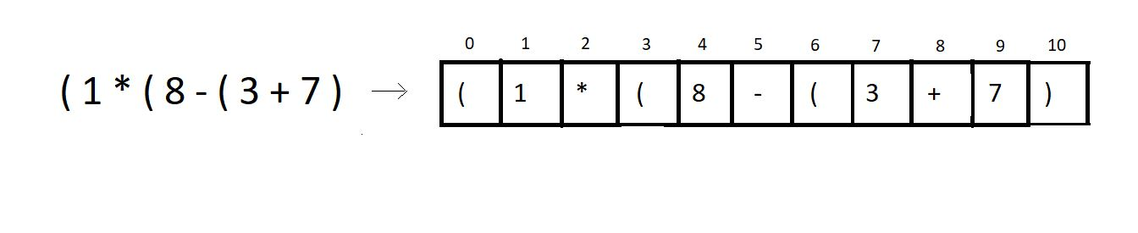

We’ll try checking if the above expression has balanced parentheses or not.

**Step 1:** Iterate through the char array, and push the opening brackets at positions 0, 3, 6 inside the stack.

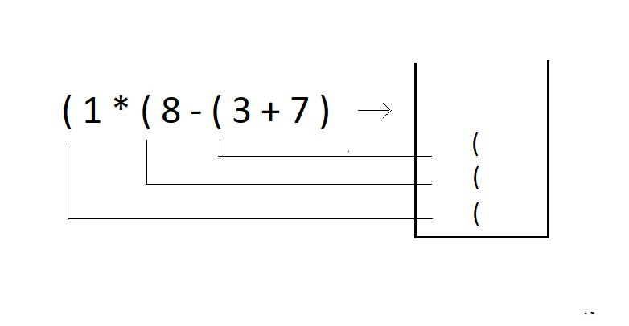

**Step 2:** Try popping an opening bracket from the stack when you encounter a closing bracket in the expression.

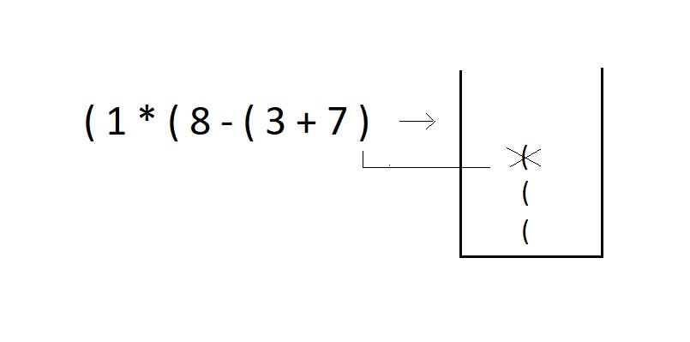

**Step 3:**Since we reached the EOE and there are still two parentheses left in the stack, we declare this expression of parentheses **unbalanced**.

I have one task for you as well. Try checking if these expressions are balanced or not. And also, tell the number of times you had to push or pop in the stack. Also, comment on the time complexity of this algorithm. Answer the best and the worst runtime complexity for an expression of size n.

1. **7 - ( 8 ( 3 * 4 ) + 11 + 12 ) ) - 8 )**

# Parenthesis Checking Using Stack in C Language

In the last tutorial, we tried making parentheses matching intuitive and more understandable using stacks. We followed one simple algorithm to accomplish that.

The algorithm states:

* Everytime you come across an opening parenthesis, push it in the stack.
* Everytime you come across a closing parenthesis, pop one opening parenthesis out from the stack.
* We call this match of parentheses unbalanced when we encounter either of the two of these troubles:

1. There is no more opening bracket inside the stack to pop, and you come across a closing bracket.
2. The stack size is not zero, or there are still more than zero opening brackets present in the stack after you come across EOE(end-of-expression).

So, that was a quick revision of the things we learned in the previous tutorial. We did enough examples in the previous tutorial; you can check them as well. In today's lesson, we will program the algorithm in C.

**Understanding the code snippet below:**

1. Start by creating an integer function paranthesisMatch, and pass the reference to a character array(expression) exp in the function as a parameter. This function will return 1 if the parentheses are balanced and zero otherwise.

2. Inside that function, create a stack pointer sp. And initialize the size member to some big number, let it be 100. Initialize the top to -1, and assign the array pointer a memory location in the heap. You have the freedom to choose any data structure you want to implement this stack. We have learned stacks using both arrays and linked lists very efficiently.

struct stack* sp;

sp->size = 100;

sp->top = -1;

sp->arr = (char *)malloc(sp->size * sizeof(char));

***Code Snippet 1: Creating and Initialising stack array.***

3. So, it would be better if you just copy everything of stack implementation because it will more or less remain the same for that part. I’ll use the array one.

4. Change the datatype of the array from integer to char. Accordingly, change everything from integer to char. And arr to exp.

5. Run a loop starting from the beginning of the expression till it reaches EOE.

6. If the current character of the expression is an opening parenthesis,’(' , push it into the stack using the push operation.

7. Else if the current character is a closing parenthesis ‘)’, see if the stack is not empty, using isEmpty, and if it is, return 0 there itself, else pop the topmost character using pop operation.

8. In the end, if the stack becomes empty, return 1, else 0.

9. In the main, define a random character array expression and just passing this expression to parenthesisMatch would do our job.

**Code for parentheses matching:**

int parenthesisMatch(char * exp){

// Create and initialize the stack

struct stack* sp;

sp->size = 100;

sp->top = -1;

sp->arr = (char *)malloc(sp->size * sizeof(char));

for (int i = 0; exp[i]!='\0'; i++)

{

if(exp[i]=='('){

push(sp, '(');

}

else if(exp[i]==')'){

if(isEmpty(sp)){

return 0;

}

pop(sp);

}

}

if(isEmpty(sp)){

return 1;

}

else{

return 0;

}

}

**Code Snippet 2: Creating the *parenthesisMatch function***

**Here is the whole source code:**

#include <stdio.h>

#include <stdlib.h>

struct stack

{

int size;

int top;

char *arr;

};

int isEmpty(struct stack *ptr)

{

if (ptr->top == -1)

{

return 1;

}

else

{

return 0;

}

}

int isFull(struct stack *ptr)

{

if (ptr->top == ptr->size - 1)

{

return 1;

}

else

{

return 0;

}

}

void push(struct stack* ptr, char val){

if(isFull(ptr)){

printf("Stack Overflow! Cannot push %d to the stack\n", val);

}

else{

ptr->top++;

ptr->arr[ptr->top] = val;

}

}

char pop(struct stack* ptr){

if(isEmpty(ptr)){

printf("Stack Underflow! Cannot pop from the stack\n");

return -1;

}

else{

char val = ptr->arr[ptr->top];

ptr->top--;

return val;

}

}

int parenthesisMatch(char * exp){

// Create and initialize the stack

struct stack* sp;

sp->size = 100;

sp->top = -1;

sp->arr = (char *)malloc(sp->size * sizeof(char));

for (int i = 0; exp[i]!='\0'; i++)

{

if(exp[i]=='('){

push(sp, '(');

}

else if(exp[i]==')'){

if(isEmpty(sp)){

return 0;

}

pop(sp);

}

}

if(isEmpty(sp)){

return 1;

}

else{

return 0;

}

}

int main()

{

char * exp = "((8)(*--$$9))";

// Check if stack is empty

if(parenthesisMatch(exp)){

printf("The parenthesis is matching");

}

else{

printf("The parenthesis is not matching");

}

return 0;

}

***Code Snippet 3: A program to check for balanced parentheses.***

Let's now just see if the functions work properly. We will give it some expressions of our choice.

char * exp = "((8)(*--$$9))";

// Check if stack is empty

if(parenthesisMatch(exp)){

printf("The parenthesis is matching");

}

else{

printf("The parenthesis is not matching");

}

***Code Snippet 4: Calling the parenthesisMatch function***

The output we received was:

The parenthesis is matching

PS D:\MyData\Business\code playground\Ds & Algo with Notes\Code>

***Figure 1: Output of the above program***

Let’s see for some another expression:

char * exp = "8)*(9)";

// Check if stack is empty

if(parenthesisMatch(exp)){

printf("The parenthesis is matching");

}

else{

printf("The parenthesis is not matching");

}

***Code Snippet 5: Calling the parenthesisMatch function for another expression***

The output we received was:

The parenthesis is not matching

PS D:\MyData\Business\code playground\Ds & Algo with Notes\Code>

***Figure 2: Output of the above program***

**Note:**Parenthesis matching nowhere tells us if the given expression is mathematically valid or not. Because it is not supposed to, this algorithm has been meant just to return whether the parentheses in the expression are balanced or not.

For e.g., the expression ((8)(*9)) is mathematically invalid but has balanced parentheses.

# Multiple Parenthesis Matching Using Stack with C Code

In the last tutorial, we saw the implementation of parentheses matching using stacks in C. One thing you must have observed is that we used only one type of parenthesis throughout the tutorial. But in mathematics, we have expressions consisting of all three types of parenthesis. Today we will be interested in matching parentheses when all three types of parentheses are used in any expression. This is what we called multi-parenthesis matching.

If you remember, parenthesis matching has nothing to do with the validity of the expression. It just tells whether an expression has all the parentheses balanced or not. A balanced parentheses expression has a corresponding closing parenthesis to all of its opening parentheses. When we talk about matching multi parenthesis, our focus is mainly on the three types of an opening parenthesis, [ { ( and their corresponding closing parentheses, ) } ]. So, basically, this tutorial is just an extension of what we learned in the previous two.

Modifying what we did earlier to make it work for multi-matching needs very little attention. Just follow these steps:

1. Whenever we encounter an opening parenthesis, we simply push it in the stack, similar to what we did earlier.

2. And when we encounter a closing parenthesis, the following conditions should be met to declare its balance:

* Before we pop, this size of the stack must not be zero.
* The topmost parenthesis of the stack must match the type of closing parenthesis we encountered.

3. If we find a corresponding opening parenthesis with conditions in point 2 met for every closing parenthesis, and the stack size reduces to zero when we reach EOE, we declare these parentheses, matching or balanced. Otherwise not matching or unbalanced.

So, basically, we modified the pop operation. And that's all. Let's see what additions to the code we would like to make. But before that follow the illustration below to get a better understanding of the algorithm.

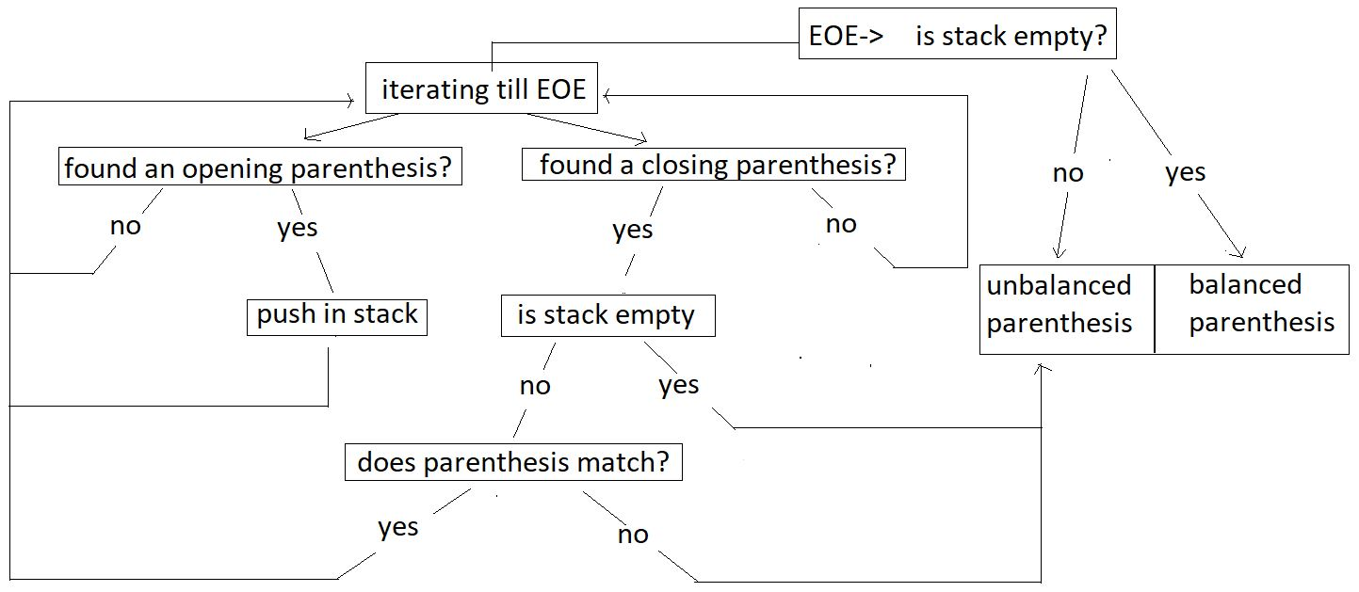

**Example:**

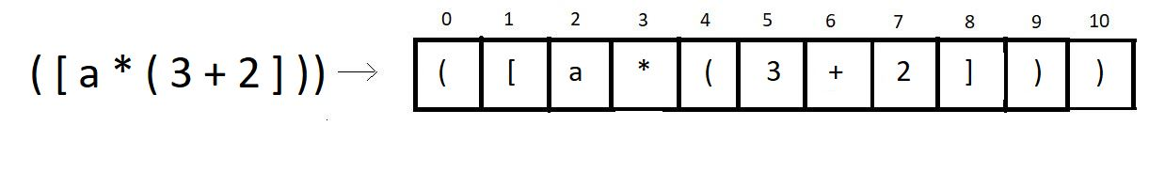

We’ll try checking if the above expression has balanced multi-parentheses or not.

**Step 1:** Iterate through the char array, and push the opening brackets of all types at positions 0, 1, 4 inside the stack.

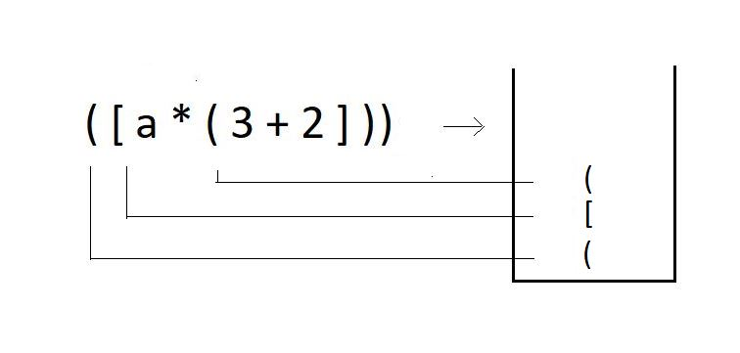

**Step 2:** When you encounter a closing bracket of any type in the expression, try checking if the kind of closing bracket you have got matches with the topmost bracket in the stack.

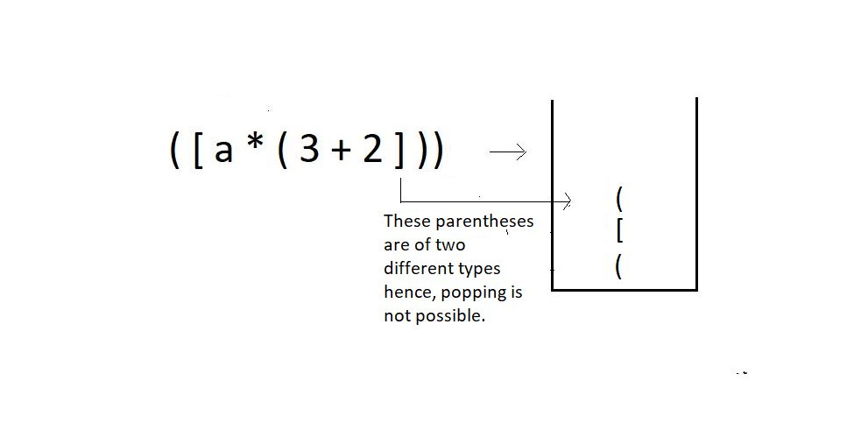

**Step 3:**Since we couldn’t pop an opening bracket corresponding to a closed bracket, we would just end the program here, declaring the parentheses **unbalanced**.

The modified function should follow this algorithm. Let’s now move to our editors.

**Understanding the code snippet below:**

1. Since in this tutorial, our main focus is to modify the code for matching parenthesis of a single type to matching multi parentheses., we’ll copy the whole thing from our last tutorial, from creating the function parenthesisMatch to the stack inside.

2. It is important to copy everything because a lot of things will remain the same. We make zero changes in the declaration of the stack and its members.

3. Run a loop starting from the beginning of the expression till it reaches EOE.

4. If the current character of the expression is an opening parenthesis, be it of any type,’(‘, ‘[’, ’{’, push it into the stack using the push operation.

5. Else if the current character is a closing parenthesis of any type ‘)’, ‘]’, ’}’, see if the stack is not empty, using isEmpty, and if it is, return 0 there itself, else pop the topmost character using pop operation and store it in another character variable named popped_ch declared globally.

6. Create an integer function, match which will get the characters, popped_ch, and the current character of the expression as two parameters. Inside this function, check if these two characters are the same. If they are the same, return 1, else 0.

int match(char a, char b){

if(a=='{' && b=='}'){

return 1;

}

if(a=='(' && b==')'){

return 1;

}

if(a=='[' && b==']'){

return 1;

}

return 0;

}

***Code Snippet 1: Creating the match function***

6. If the match function returns 1, our pop operation is successful, and we can continue checking further characters; else, if it returns 0, end the program here itself and return 0 to the main.

7. And if things went well throughout, and in the end, if the stack becomes empty, return 1, else 0.

**Code for multi parentheses matching:**

int parenthesisMatch(char * exp){

// Create and initialize the stack

struct stack* sp;

sp->size = 100;

sp->top = -1;

sp->arr = (char *)malloc(sp->size * sizeof(char));

char popped_ch;

for (int i = 0; exp[i]!='\0'; i++)

{

if(exp[i]=='(' || exp[i]=='{' || exp[i]=='['){

push(sp, exp[i]);

}

else if(exp[i]==')'|| exp[i]=='}' || exp[i]==']'){

if(isEmpty(sp)){

return 0;

}

popped_ch = pop(sp);

if(!match(popped_ch, exp[i])){

return 0;

}

}

}

if(isEmpty(sp)){

return 1;

}

else{

return 0;

}

}

***Code Snippet 2: Creating the modified parenthesisMatch function***

**Here is the whole source code:**

#include <stdio.h>

#include <stdlib.h>

struct stack

{

int size;

int top;

char *arr;

};

int isEmpty(struct stack *ptr)

{

if (ptr->top == -1)

{

return 1;

}

else

{

return 0;

}

}

int isFull(struct stack *ptr)

{

if (ptr->top == ptr->size - 1)

{

return 1;

}

else

{

return 0;

}

}

void push(struct stack* ptr, char val){

if(isFull(ptr)){

printf("Stack Overflow! Cannot push %d to the stack\n", val);

}

else{

ptr->top++;

ptr->arr[ptr->top] = val;

}

}

char pop(struct stack* ptr){

if(isEmpty(ptr)){

printf("Stack Underflow! Cannot pop from the stack\n");

return -1;

}

else{

char val = ptr->arr[ptr->top];

ptr->top--;

return val;

}

}

char stackTop(struct stack* sp){

return sp->arr[sp->top];

}

int match(char a, char b){

if(a=='{' && b=='}'){

return 1;

}

if(a=='(' && b==')'){

return 1;

}

if(a=='[' && b==']'){

return 1;

}

return 0;

}

int parenthesisMatch(char * exp){

// Create and initialize the stack

struct stack* sp;

sp->size = 100;

sp->top = -1;

sp->arr = (char *)malloc(sp->size * sizeof(char));

char popped_ch;

for (int i = 0; exp[i]!='\0'; i++)

{

if(exp[i]=='(' || exp[i]=='{' || exp[i]=='['){

push(sp, exp[i]);

}

else if(exp[i]==')'|| exp[i]=='}' || exp[i]==']'){

if(isEmpty(sp)){

return 0;

}

popped_ch = pop(sp);

if(!match(popped_ch, exp[i])){

return 0;

}

}

}

if(isEmpty(sp)){

return 1;

}

else{

return 0;

}

}

int main()

{

char * exp = "[4-6]((8){(9-8)})";

if(parenthesisMatch(exp)){

printf("The parenthesis is balanced");

}

else{

printf("The parenthesis is not balanced");

}

return 0;

}

***Code Snippet 3: A program to check for balanced multi-parentheses.***

Let's try the functions now and see if they work. We will give it some random expressions of our choice.

char * exp = "((8){(9-8)})";

// Check if stack is empty

if(parenthesisMatch(exp)){

printf("The parenthesis is matching");

}

else{

printf("The parenthesis is not matching");

***Code Snippet 4: Calling the parenthesisMatch function***

The output we received was:

The parenthesis is matching

PS D:\MyData\Business\code playground\Ds & Algo with Notes\Code>

**Figure 1: Output of the above program**

Let’s see for some another expression:

char * exp = "[[4-6]((8){(9-8])})";

if(parenthesisMatch(exp)){

printf("The parenthesis is balanced");

}

else{

printf("The parenthesis is not balanced");

}

***Code Snippet 5: Calling the parenthesisMatch function for another expression***

The output we received was:

The parenthesis is not matching

PS D:\MyData\Business\code playground\Ds & Algo with Notes\Code>

***Figure 2: Output of the above program***

**Infix, Prefix and Postfix Expressions**

We have finished learning matching parentheses in the last tutorial. It is always great to see the applications of what you learn, and parentheses matching was one such application of stacks. Today we'll start another one, called infix, prefix, and postfix expressions.

**What are these?**

The three terms, infix prefix, and postfix will be dealt with individually later. In general, these are **the notations to write an expression**. Mathematical expressions have been taught to us since childhood. Writing expressions to add two numbers for subtraction, multiplication, or division. They were all expressed through certain expressions. That's what we're learning today: different expressions.

**Infix:**

This is the method we have all been studying and applying for all our academic life. Here the operator comes in between two operands. And we say, two is added to three. For eg: 2 + 3, a * b, 6 / 3 etc.

< operand 1 >< **operator** >< operand2 >

**Prefix:**

This method might seem new to you, but we have vocally used them a lot as well. Here the operator comes before the two operands. And we say, Add two and three. For e.g.:  + 6 8, * x y, -  3 2 etc.

<**operator**>< operand 1 >< operand2 >

**Postfix:**

This is the method that might as well seem new to you, but we have used even this in our communication. Here the operator comes after the two operands. And we say, Two and three are added. For e.g.:  5 7 +, a  b *,  12 6 / etc.

< operand 1 >< operand2 >< **operator** >

To understand the interchangeability of these terms, please refer to the table below.

|  |  |  |  |
| --- | --- | --- | --- |
|  | **Infix** | **Prefix** | **Postfix** |
| 1. | a * b | * a b | a b * |
| 2. | a - b | -  a b | a b - |

So far, we have been dealing with just two operands, but a mathematical expression can hold a lot more. We will now learn to change a general infix mathematical expression to its prefix and postfix relatives. But before that, it is better to understand why we even need these methods.

**Why these methods?**

When we evaluate a mathematical expression, we have a rule in mind, named BODMAS, where we have operators’ precedence in this order; brackets, of, division, multiplication, addition, subtraction. But what would you do when you get to evaluate a 1000 character long-expression, or even longer one? You will try to automate the process. But there is one issue. Computers don’t follow BODMAS; rather, they have their own operator precedence. And this is where we need these postfix and prefix notations. In programming, we use postfix notations more often, likewise, following the precedence order of machines.

Consider the expression a* ( b + c ) * d; since computers go left to right while evaluating an expression, we’ll convert this infix expression to its postfix form.

The following table lists the precedence and associativity of C operators. Operators are listed top to bottom, in descending precedence.

|  |  |  |  |
| --- | --- | --- | --- |
| **Precedence** | **Operator** | **Description** | **Associativity** |
| **1** | ++ -- | Suffix/postfix increment and decrement | Left-to-right |
| () | Function call |
| [] | Array subscripting |
| . | Structure and union member access |
| -> | Structure and union member access through pointer |
| (*type*){*list*} | Compound literal(C99) |
| **2** | ++ -- | Prefix increment and decrement[[note 1]](https://en.cppreference.com/w/c/language/operator_precedence#cite_note-1) | Right-to-left |
| + - | Unary plus and minus |
| ! ~ | Logical NOT and bitwise NOT |
| (*type*) | Cast |
| * | Indirection (dereference) |
| & | Address-of |
| sizeof | Size-of[[note 2]](https://en.cppreference.com/w/c/language/operator_precedence#cite_note-2) |
| _Alignof | Alignment requirement(C11) |
| **3** | * / % | Multiplication, division, and remainder | Left-to-right |
| **4** | + - | Addition and subtraction |
| **5** | << >> | Bitwise left shift and right shift |
| **6** | < <= | For relational operators < and ≤ respectively |
| > >= | For relational operators > and ≥ respectively |
| **7** | == != | For relational = and ≠ respectively |
| **8** | & | Bitwise AND |
| **9** | ^ | Bitwise XOR (exclusive or) |
| **10** | | | Bitwise OR (inclusive or) |
| **11** | && | Logical AND |
| **12** | || | Logical OR |
| **13** | ?: | Ternary conditional[[note 3]](https://en.cppreference.com/w/c/language/operator_precedence#cite_note-3) | Right-to-left |
| **14**[[note 4]](https://en.cppreference.com/w/c/language/operator_precedence#cite_note-4) | = | Simple assignment |
| += -= | Assignment by sum and difference |
| *= /= %= | Assignment by product, quotient, and remainder |
| <<= >>= | Assignment by bitwise left shift and right shift |
| &= ^= |= | Assignment by bitwise AND, XOR, and OR |
| **15** | , | Comma | Left-to-right |

Its postfix form is, a b c + * d *.  You must be wondering how we got here. Refer to the illustration below.

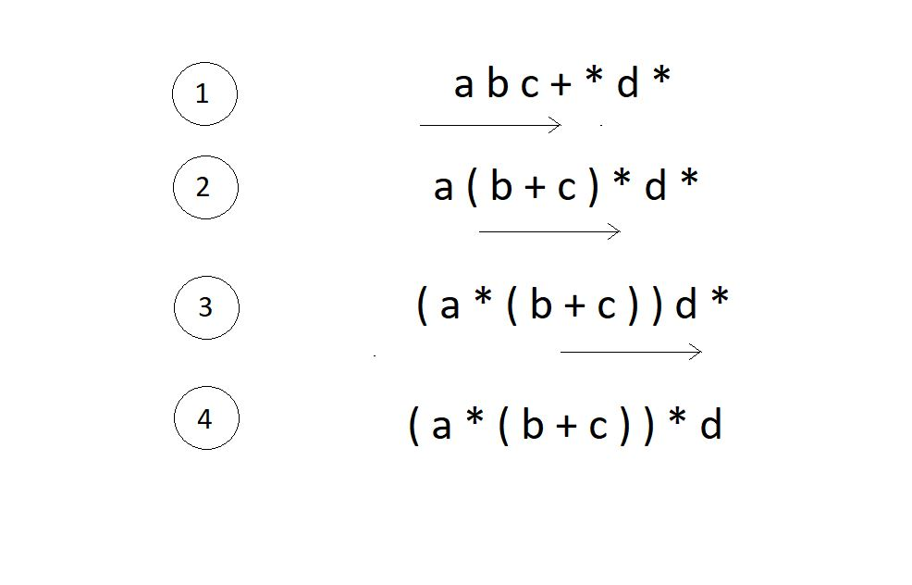

We have successfully reached what we wanted the machine to do. Now the kick is in converting infixes to postfixes and prefixes.

**Converting infix to prefix:**

Consider the expression, **x - y * z**.

1. Parentheses the expression. The infix expression must be parenthesized by following the operator precedence and associativity before converting it into a prefix expression. Our expression now becomes **( x - ( y * z ) )**.

2. Reach out to the innermost parentheses. And convert them into prefix first, i.e.  **( x - ( y * z ) )**changes to **( x - [ * y z ] )**.

3. Similarly, keep converting one by one, from the innermost to the outer parentheses.  **( x - [ * y z ] )  → [ - x * y z ].**

4. And we are done.

**Converting infix to postfix:**

Consider the same expression, **x - y * z**.

5. Parentheses the expression as we did previously. Our expression now becomes **( x - ( y * z ) )**.

6. Reach out to the innermost parentheses. And convert them into postfix first, i.e.  **( x - ( y * z ) )**changes to **( x - [ y z * ] )**.

7. Similarly, keep converting one by one, from the innermost to the outer parentheses.  **( x - [ y z * ] )  → [ x y z * - ].**

8. And we are done.

Similarly the expression p - q -  r / a, follows the following conversions to become a prefix expression:

* **p - q -  r / a**  →  ( ( p - q ) -  ( r / a ) ) →  ( [ - p q ] - [ / r a ]  )  →**- - p q / r a**

**Quick Quiz:**Convert the above infix expression into its postfix form.

**Note:**You cannot change the expression given to you. For eg. ( p - q ) * ( m - n ) cannot be changed to something like ( p - ( q * m ) - n ).

Let’s change this to its postfix equivalent.

* **( p - q ) * ( m - n )**→  ( ( p - q ) * ( m - n ) ) →  ( [p q - ] *[m n - ] )  →****p q-m n -***

# Infix To Postfix Using Stack

In the last tutorial, we had learned to convert an infix expression to its postfix and prefix equivalents manually. Following were the simple steps we followed.

1. Parenthesize the expression following the operators’ precedence and their associativity.
2. From the innermost to outermost, keep converting the expressions.

But we didn’t talk about their implementation using stacks; rather, we didn’t even mention stacks in our last class. Today, we will learn how to convert an infix expression into its postfix equivalent using stacks.

Converting an infix expression to its postfix counterpart needs you to follow certain steps. The following are the steps:

1. Start moving left to right from the beginning of the expression.
2. The moment you receive an operand, concatenate it to the postfix expression string.
3. And the moment you encounter an operator, move to the stack along with its relative precedence number and see if the topmost operator in the stack has higher or lower precedence. If it's lower, push this operator inside the stack. Else, keep popping operators from the stack and concatenate it to the postfix expression until the topmost operator becomes weaker in precedence relative to the current operator.
4. If you reach the EOE, pop every element from the stack, and concatenate them as well. And the expression you will receive after doing all the steps will be the postfix equivalent of the expression we were given.

For our understanding today, let us consider the expression **x - y / z - k * a.**Step by step, we will turn this expression into its postfix equivalent using stacks.

1. We will start traversing from the left.

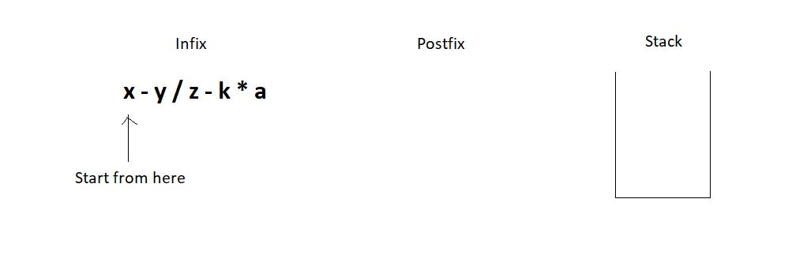

2. First, we got the letter ‘x’. We just pushed it into the postfix string. Then we got the subtraction symbol ‘-’, and we push it into the stack since the stack is empty.

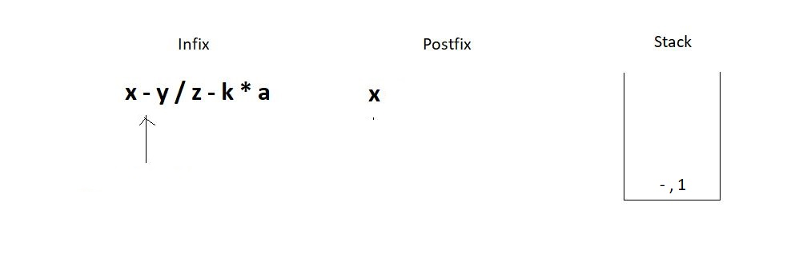

3. Similarly, we push the division operator in the stack since the topmost operator has a precedence number 1, and the division has 2.

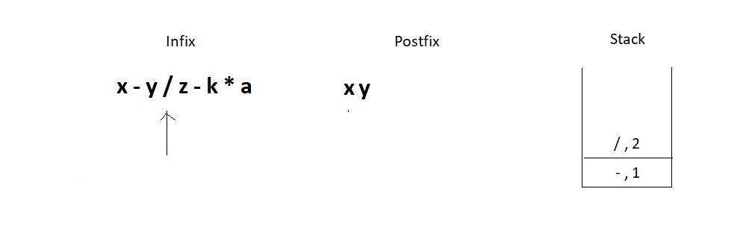

4. The next operator we encounter is again a subtraction. Since the topmost operator in the stack has an operator precedence number 2, we would pop elements out from the stack until we can push the current operator. This leads to removing both the present operators in the stack since they are both greater or equal in precedence. Don’t forget to concatenate the popped operators to the postfix expression.

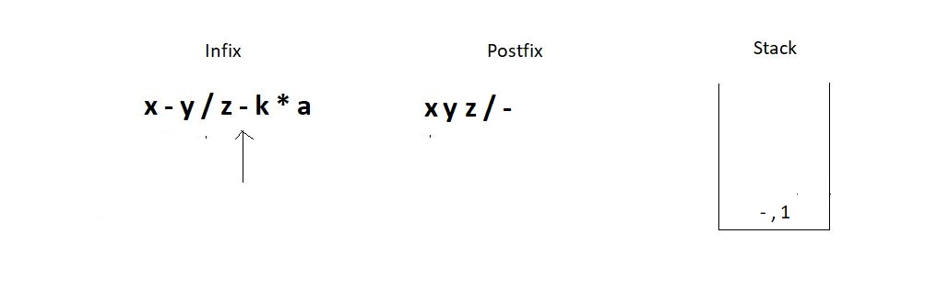

5. Next, we have a multiplication operator whose precedence number is 2 relative to the topmost operator in the stack. Hence we simply push it in the stack.

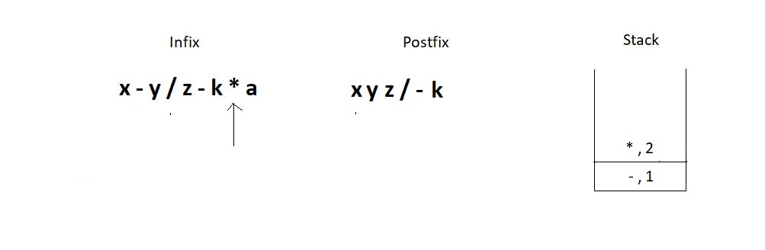

6. And then we get to the EOE and still have two elements inside the stack. So, just pop them one by one, and concatenate them to the postfix. And this is when we succeed in converting the infix to the postfix expression.

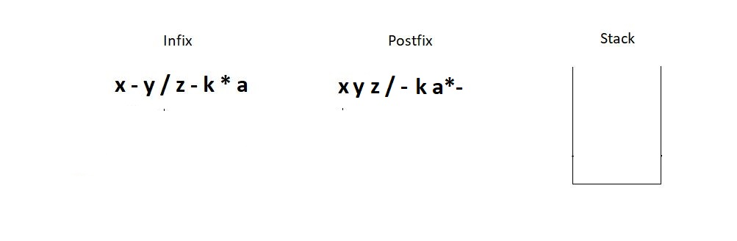

Follow every step meticulously, and you will find it very easy to master this. You can see if the answer we found at the end is correct manually.

* **x - y / z - k * a** →  (( x - ( y / z )) - ( k * a )) →  (( x - [ y z / ]) - [ k a * ]  )  → [ x y z / - ] - [ k a * ]  →**x y z / - k a * -**

And it is indeed a correct conversion. I would now want you to follow the same steps and convert the expression**x + y * z - k,**using the stack method, and verify your answer manually using parentheses.

# Coding Infix to Postfix in C using Stack

We saw earlier how infix expressions can be converted to their other equivalents manually. But when it came to automating the process, we took a different path. We used stacks to take hold of the operators we encountered in the expression. We followed an algorithm to convert an infix expression to its postfix equivalent, which in short, said:

1. We create a string variable that will hold our postfix expression. We start moving from the left to the right. And the moment we receive an operand, we concatenate it to the postfix string. And whenever we encounter an operator, we proceed with the following steps:

* Keep in account the operator and its relative precedence.
* If either the stack is empty or its topmost operator has lower relative precedence, push this operator-precedence pair inside the stack.
* Else, keep popping operators from the stack and concatenate it to the postfix expression until the topmost operator becomes weaker in precedence relative to the current operator.

2. If you reach the EOE, pop every element from the stack, if there is any, and concatenate them as well. And there, you’ll have your postfix expression.

Let us now see the program pursuing the conversion. I have attached the snippets alongwith. Keep checking them while you understand the codes.

**Understanding the program for infix to postfix conversion:**

1. First of all, create a character pointer function infixToPostfix since the function has to return a character array. And now pass into this function the given expression, which is also a character pointer.

2. Define a struct stack pointer variable sp. And give it the required memory in the heap. Create the instance. It’s safe to assume that a struct stack element and all its basic operations, push, pop, etc., have already been defined. You better copy everything from the stack tutorial.

3. Create a character array/pointer postfix, and assign it sufficient memory to hold all the characters of the infix expression in the heap.

4. Create two counters, one to traverse through the infix and another to traverse and insert in the postfix. Refer to the illustration below, which describes the initial conditions.

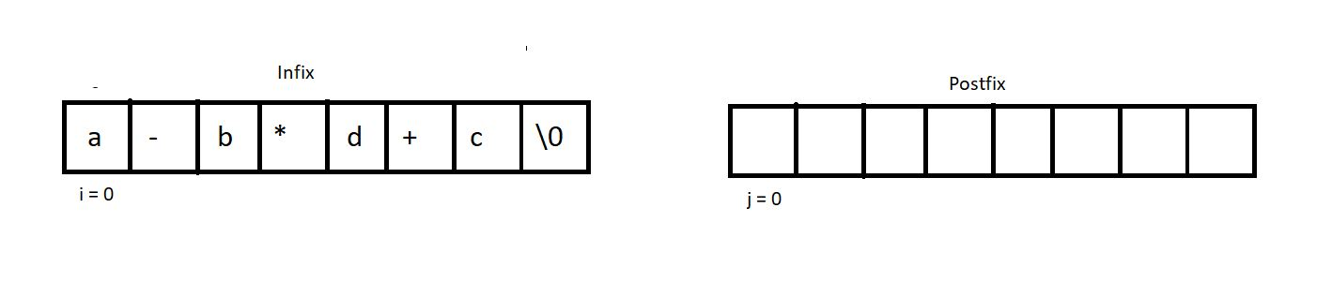

5. Run a while loop until we reach the EOE of the infix. And inside that loop, check if the current index holds an operator, and if it’s not, add that character into the postfix and increment both the counters by 1. And if it does hold an operator, call another function that would check if the precedence of the stackTop is less than the precedence of the current operator. If yes, push it inside the stack. Else, pop the stackTop, and add it back into the postfix. Increment j by 1.

char* infixToPostfix(char* infix){

struct stack * sp = (struct stack *) malloc(sizeof(struct stack));

sp->size = 10;

sp->top = -1;

sp->arr = (char *) malloc(sp->size * sizeof(char));

char * postfix = (char *) malloc((strlen(infix)+1) * sizeof(char));

int i=0; // Track infix traversal

int j = 0; // Track postfix addition

while (infix[i]!='\0')

{

if(!isOperator(infix[i])){

postfix[j] = infix[i];

j++;

i++;

}

else{

if(precedence(infix[i])> precedence(stackTop(sp))){

push(sp, infix[i]);

i++;

}

else{

postfix[j] = pop(sp);

j++;

}

}

}

while (!isEmpty(sp))

{

postfix[j] = pop(sp);

j++;

}

postfix[j] = '\0';

return postfix;

}

***Code Snippet 1: Creating the function infixToPostfix***

6. It’s now time to create the two functions to make this conversion possible. isOperator & precedence which checks if a character is an operator and compares the precedence of two operators respectively.

7. Create an integer function isOperator which takes a character as its parameter and returns 2, if it's an operator, and 0 otherwise.

int isOperator(char ch){

if(ch=='+' || ch=='-' ||ch=='*' || ch=='/')

return 1;

else

return 0;

}

***Code Snippet 2: Creating the function isOperator***

8. Create another integer function precedence, which takes a character as its parameter, and returns its relative precedence. It returns 3 if it’s a ‘/’ or a ‘*’. And 2 if it's a ‘+’ or a ‘-’.

9. If we are still left with any element in the stack at the end, pop them all and add them to the postfix.

int precedence(char ch){

if(ch == '*' || ch=='/')

return 3;

else if(ch == '+' || ch=='-')

return 2;

else

return 0;

}

**Code Snippet 3: Creating the function precedence**

And we have successfully finished writing the codes.

Here is the whole source code:

#include <stdio.h>

#include <stdlib.h>

#include <string.h>

struct stack

{

int size;

int top;

char *arr;

};

int stackTop(struct stack* sp){

return sp->arr[sp->top];

}

int isEmpty(struct stack *ptr)

{

if (ptr->top == -1)

{

return 1;

}

else

{

return 0;

}

}

int isFull(struct stack *ptr)

{

if (ptr->top == ptr->size - 1)

{

return 1;

}

else

{

return 0;

}

}

void push(struct stack* ptr, char val){

if(isFull(ptr)){

printf("Stack Overflow! Cannot push %d to the stack\n", val);

}

else{

ptr->top++;

ptr->arr[ptr->top] = val;

}

}

char pop(struct stack* ptr){

if(isEmpty(ptr)){

printf("Stack Underflow! Cannot pop from the stack\n");

return -1;

}

else{

char val = ptr->arr[ptr->top];

ptr->top--;

return val;

}

}

int precedence(char ch){

if(ch == '*' || ch=='/')

return 3;

else if(ch == '+' || ch=='-')

return 2;

else

return 0;

}

int isOperator(char ch){

if(ch=='+' || ch=='-' ||ch=='*' || ch=='/')

return 1;

else

return 0;

}

char* infixToPostfix(char* infix){

struct stack * sp = (struct stack *) malloc(sizeof(struct stack));

sp->size = 10;

sp->top = -1;

sp->arr = (char *) malloc(sp->size * sizeof(char));

char * postfix = (char *) malloc((strlen(infix)+1) * sizeof(char));

int i=0; // Track infix traversal

int j = 0; // Track postfix addition

while (infix[i]!='\0')

{

if(!isOperator(infix[i])){

postfix[j] = infix[i];

j++;

i++;

}

else{

if(precedence(infix[i])> precedence(stackTop(sp))){

push(sp, infix[i]);

i++;

}

else{

postfix[j] = pop(sp);

j++;

}

}

}

while (!isEmpty(sp))

{

postfix[j] = pop(sp);

j++;

}

postfix[j] = '\0';

return postfix;

}

int main()

{

char * infix = "x-y/z-k*d";

printf("postfix is %s", infixToPostfix(infix));

return 0;

}

***Code Snippet 4: Source code for the function infixToPostfix***

We now need to check the function for some expressions to see if it works.

char * infix = "x-y/z-k*d";

printf("postfix is %s", infixToPostfix(infix));

***Code Snippet 5: Calling the function infixToPostfix***

postfix is xyz/-kd*-

PS D:\MyData\Business\code playground\Ds & Algo with Notes\Code>

***Figure 1: Output of the above program***